**How To Use Essential Oil Roller Bottles:**

1. Add 15-30 drops of essential oil (or oils) to a [10ml Roller Bottle](http://www.lovingessentialoils.com/collections/roller-bottles/products/blue-glass-roll-on-bottles-set-of-12)
2. Fill rest of bottle with carrier oil of choice (jojoba oil, fractionated coconut oil, sweet almond oil, etc)
3. Add top and shake well to mix, label bottle and you are ready to roll!

[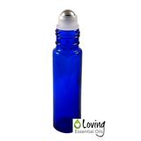](http://www.lovingessentialoils.com/collections/roller-bottles/products/blue-glass-roll-on-bottles-set-of-12)Need roller bottles? We offer high quality blue glass roller bottles that are durable and include a stainless steel roller ball for smooth application. [Click here to buy our blue roller bottles that are pictured in this post -  FREE Shipping!](http://www.lovingessentialoils.com/collections/roller-bottles/products/blue-glass-roll-on-bottles-set-of-12)

**Tips for Roller Bottles**

Roller bottles can be rolled onto just about any body part with a few exceptions.  Keep away from eyes, inside ears and mucous membranes to prevent irritation.  Favorite places to roll oils on are [bottoms of feet](http://www.lovingessentialoils.com/blogs/essential-oil-tips/69315843-why-would-i-put-essential-oils-on-my-feet), neck, behind ears, wrists, temples, chest, spine/back and belly.

You can use just single oils in the roller bottle like peppermint, lavender, melaleuca, or frankincense.  Having these oils diluted in a carrier oil ready for application will be a real time and money saver.

[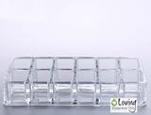](http://www.lovingessentialoils.com/collections/clearance-sale/products/essential-oil-organizer-for-roller-bottles)If your oil brand has premade oil blends, you can use those blends as well.  Start with 15 drops of your favorite oil brands premade blend, then add the carrier oil.  If using on a child, you may want to start with only 10 drops of essential oils. [Want to keep all your roller bottles together and ready for use? Click here to buy our roller bottle organizer.](http://www.lovingessentialoils.com/collections/clearance-sale/products/essential-oil-organizer-for-roller-bottles)

Need some inspiration for what eo blends to make?  Check out our list of essential oil roller recipes below.  You are guaranteed to find a recipe, be sure to share this guide as well with others on Pinterest, Facebook or Twitter.

**Recipes For Essential Oil Roller Bottles:**

[Click here to download a PDF of the recipe guide below!](https://cdn.shopify.com/s/files/1/0956/7354/files/EO_Roller_Recipe_Guide.pdf?11039784557125066786)

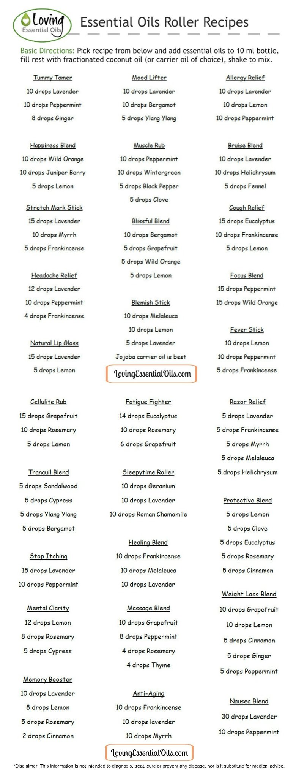

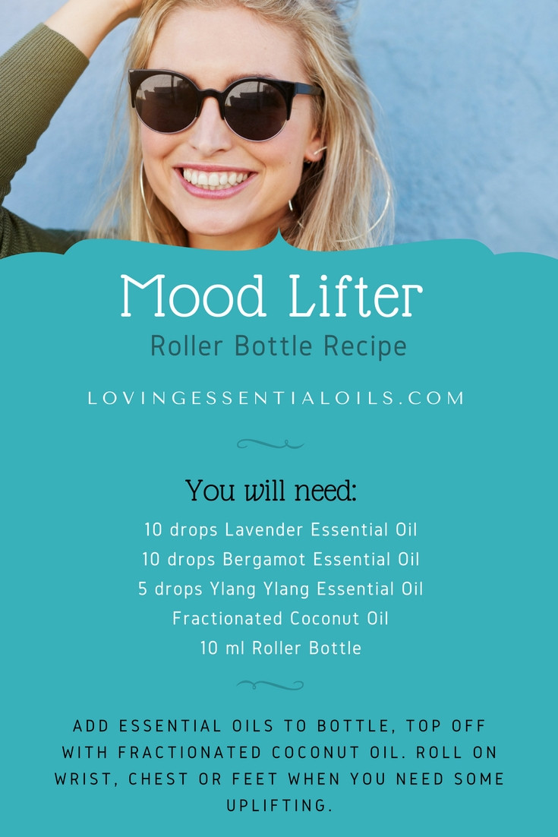

* [Home](http://redefinedmom.com/)
* [About](http://redefinedmom.com/about-2/)
* [Advertising/PR](https://redefinedmom.com/advertising-and-pr/)
* [Media Mentions](https://redefinedmom.com/media-mentions/)
* [Contact](https://redefinedmom.com/contact/)

Top of Form

Bottom of Form

[https://redefinedmom.com/wp-content/uploads/2014/08/facebook.jpg](https://www.facebook.com/TheRedefinedMom)[https://redefinedmom.com/wp-content/uploads/2014/08/twitter.jpg](https://twitter.com/TheRedefinedMom)[https://redefinedmom.com/wp-content/uploads/2014/08/pinterest.jpg](http://www.pinterest.com/KellyLSnyder/)[https://redefinedmom.com/wp-content/uploads/2014/08/instagram.jpg](http://instagram.com/theredefinedmom)[https://redefinedmom.com/wp-content/uploads/2014/08/rss.jpg](http://feeds.feedblitz.com/redefinedmom)[https://redefinedmom.com/wp-content/uploads/2015/09/periscope.jpg](https://www.periscope.tv/theredefinedmom)

[](http://redefinedmom.com/)

* [Beauty](https://redefinedmom.com/category/beauty/)
* [Food](https://redefinedmom.com/category/food/)
  + [Recipe Index](https://redefinedmom.com/recipe-index/)
* [Life](https://redefinedmom.com/category/living/)
* [Style](https://redefinedmom.com/category/fashion-2/)
* [Whole Living](https://redefinedmom.com/category/whole-living-for-middle-age-women/)
* [Shop](https://redefinedmom.com/category/deal-alert/)

**1.7k**  
Shares

[[Pinterest](javascript:void(0);)1.4k[Facebook](javascript:void(0);)238[Google+](javascript:void(0);)1[LinkedIn](javascript:void(0);)1[Yummly](javascript:void(0);)1TwitterSumoMe](javascript:void(0);)

# 25 Essential Oil Rollerball Blends & Recipes For Families

June 25, 2015 by [Kelly](https://redefinedmom.com/author/kelly/) [46 Comments](https://redefinedmom.com/essential-oil-rollerball-blends-recipes-for-families/#comments)

This post may contain my affiliate link, which means I will make a small commission if you click and make a purchase. Also, I am a participant in the Amazon Services LLC Associates Program, which is a program designed to proved a means for sites to earn advertising fees by linking to [amazon.com](http://amazon.com/). Thank you for supporting Redefined Mom. For more information, see my [disclosure policy](http://redefinedmom.com/disclosure/).

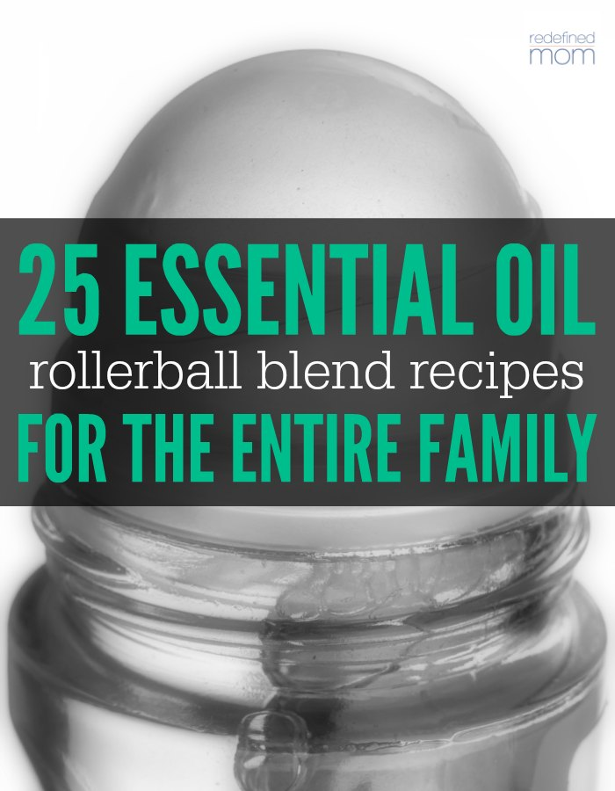

One of the best things about essential oils is their ability to solve common everyday ailments naturally vs taking an over-the-counter medicine. Most of the common items in your medicine cabinet (pain relief, sleep aids, digestive aids, cuts and wounds ointments), can be replaced with a few drops of essential oil.

Depending on the ailment our family is treating, we’ll either…use the oil and apply it directly, apply the oil directly with a carrier oil, or mix the oils together in roller bottles. And that is what I want to share with you…my personal “list” of essential oil rollerball blends & recipes for families.

There are several great things about rollerball bottles. They are premade mixtures – which saves time when something hurts; they are easy to apply – roll it on your feet, your neck, your wrists and you are ready to go; and they stretch out oils, making them last longer by using a carrier oil. (By using a carrier oil, you are not diluting the effectiveness of the oil, you are just giving your oil more coverage with help of something to carry it where you want it to go.)

# Essential Oil Rollerball Blends & Recipes For Families

Here are a couple of things you need to know and purchase before you start making your roller bottles.

* You need 10 mL glass roller bottles. These are [my favorite](http://www.amazon.com/gp/product/B005Y4ZPUW/ref=as_li_tl?ie=UTF8&camp=1789&creative=390957&creativeASIN=B005Y4ZPUW&linkCode=as2&tag=kancitmam-20&linkId=LUAEQOQZWARJLLBY).
* You need a carrier oil. I like (and use) this [avocado oil](http://www.amazon.com/gp/product/B000MGOZ30/ref=as_li_tl?ie=UTF8&camp=1789&creative=390957&creativeASIN=B000MGOZ30&linkCode=as2&tag=kancitmam-20&linkId=6J4B5WB2JCKBNHE3), [fractioned coconut oil](http://www.amazon.com/gp/product/B00NPC7EEU/ref=as_li_tl?ie=UTF8&camp=1789&creative=390957&creativeASIN=B00NPC7EEU&linkCode=as2&tag=kancitmam-20&linkId=GQBOM6SD5DCPW3JM) (my personal favorite) or [almond oil](http://www.amazon.com/gp/product/B0019LVFSU/ref=as_li_tl?ie=UTF8&camp=1789&creative=390957&creativeASIN=B0019LVFSU&linkCode=as2&tag=kancitmam-20&linkId=W6JRYEZC3BPM37AE).
* You need essential oils.
* Optional: [Plastic droppers](http://www.amazon.com/gp/product/B005Z4QVZ4/ref=as_li_tl?ie=UTF8&camp=1789&creative=390957&creativeASIN=B005Z4QVZ4&linkCode=as2&tag=kancitmam-20&linkId=WWXWCUMBAQMUJUI5). I like using these to make up my roller bottles. They are inexpensive and make sure all of the oil gets in the bottle vs on the counter or the outside of the essential oil bottle.

You’ll place the number of drops, per recipe, in a 10 mL rollerball and then fill to the top with your carrier oil of choice. Roll the blends over your neck, feet and wrists (and if applicable, the place that hurts). If there are special instructions, you’ll see them at the end of the recipe. Finally, to be most effective, apply less oil and apply it more often. 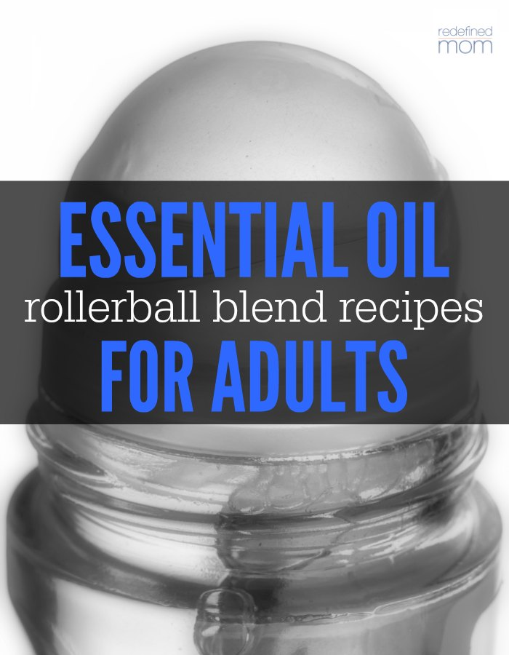

## Essential Oil Rollerball Blends & Recipes for Adults

**stress away blend for mama:**  
18 drops [balance](http://amzn.to/2dmhDpz)  
18 drops [serenity](http://amzn.to/2dmh3s4)  
18 drops [lavender](http://amzn.to/2db3nBk)  
18 drops [grapefruit](http://amzn.to/2db349r) or [citrus bliss](http://amzn.to/2dbfi5P)  
4 drops [wild orange](http://amzn.to/2cX51qn)

**peace & calming blend for mama:**  
6 drops [sandalwood](http://amzn.to/2deK1Lg)  
6 drops [ylang ylang](http://amzn.to/2cFiTCw)  
6 drops [cypress](http://amzn.to/2cFeXlg)  
6 drops [bergamot](http://amzn.to/2dbckhN)  
6 drops [black pepper](http://amzn.to/2deKmNN)

**“grounding” blend for adults:**  
2 drops [patchouli](http://amzn.to/2cFeiAh)  
2 drops [vetiver](http://amzn.to/2cEYZgd)  
2 drops [lime](http://amzn.to/2dvd2WQ)  
20 drops [balance](http://amzn.to/2ddIbM1)  
20 drops [lavender](http://amzn.to/2dbdg5y)

**upset tummy blend for adults:**  
10 drops [peppermint](http://amzn.to/2ddHfYa)  
10 drops [ginger](http://amzn.to/2cP5bkd) (or you can use a pre-made blend like [*digestzen*](http://amzn.to/2dqoJc6))

**sleep blend for adults:**  
4 drops [marjoram](http://amzn.to/2cP4UNT)  
10 drops [frankincense](http://amzn.to/2dqlD7O)  
10 drops [bergamot](http://amzn.to/2cFgGqW)  
12 drops [roman chamomile](http://amzn.to/2dbd7z7)  
12 drops [vetiver](http://amzn.to/2ddIB56)  
15 drops [lavender](http://amzn.to/2cEYT8b)  
10 drops [cedarwood](http://amzn.to/2cEYOkY)

**“liquid morphine” for adults:**  
30 drops [marjoram](http://amzn.to/2dqlwZU)  
30 drops [lemongrass](http://amzn.to/2ddIOp9)  
30 drops [frankincense](http://amzn.to/2dqlbGz)

**aching muscles blend for adults:**  
10 drops [peppermint](http://amzn.to/2cEZ2Zi)  
6 drops [clove](http://amzn.to/2dqlKQG)  
10 drops [wintergreen](http://amzn.to/2cF05Iz)  
6 drops [black pepper](http://amzn.to/2dvfA75)(Massage into achy areas.)

**body aches blend for adults:**  
10 drops [eucalyptus](http://amzn.to/2dveWqt)  
10 drops [lavender](http://amzn.to/2cEYT8b)  
10 drops [deepblue](http://amzn.to/2cEZmal" \t "_blank)

**“wakeup” blend for adults:**  
30 drops lemon  
8 drops [eucalyptus](http://amzn.to/2dveWqt)  
6 drops [peppermint](http://amzn.to/2cEZ2Zi)  
2 drops [cinnamon](http://amzn.to/2dvdZyj)

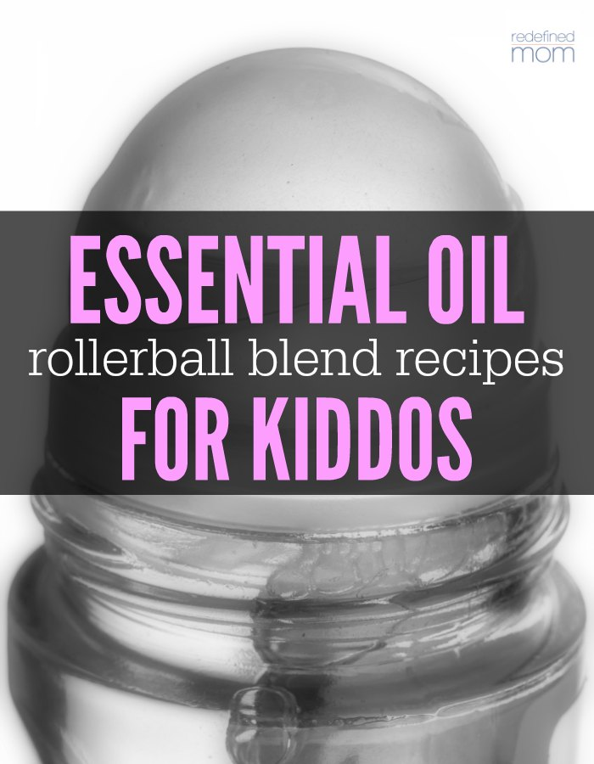

## Essential Oil Rollerball Blends & Recipes for Kids

**sleep blend for kiddos:**  
15 drops [lavender](http://amzn.to/2cEYT8b)  
10 drops [serenity](http://amzn.to/2d9IJBZ)  
5 drops [roman chamomile](http://amzn.to/2ddKwa0)

**owies blend for cuts, scrapes and bug bites for kiddos:**  
10 drops [lavender](http://amzn.to/2cEYT8b)  
10 drops of [melaleuca](http://amzn.to/2dqmXaM)  
(Apply on effected area.)

**focus on school blend for kiddos:**  
10 drops [peppermint](http://amzn.to/2cEZ2Zi)  
10 drops [wild orange](http://amzn.to/2dbeXA7)

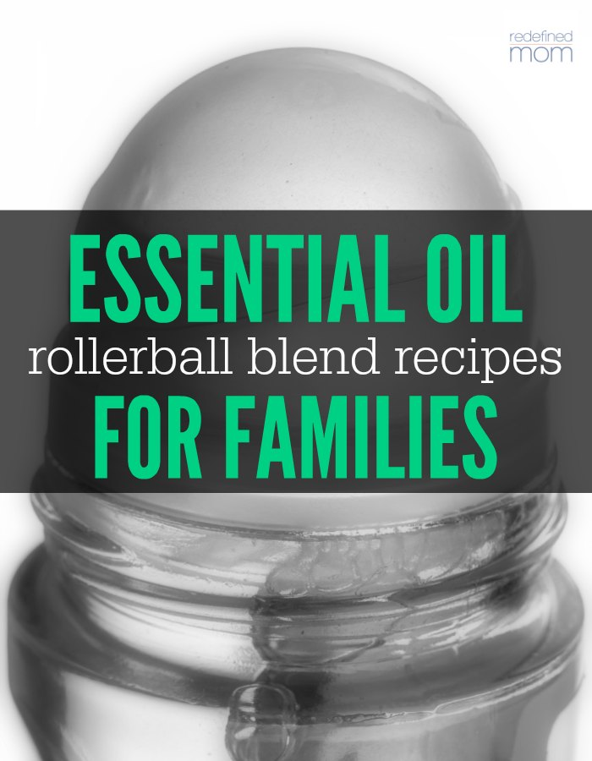

## Essential Oil Rollerball Blends & Recipes for Families

**congestion blend for families:**  
40 drops of [breathe](http://amzn.to/2dqlNfg)  
25 drops of [lime](http://amzn.to/2dbeyxF)  
(Apply over sinus, temples, and ears)

**“flu bomb” for families:**  
10 drops [oregano](http://amzn.to/2cEZfvG)  
18 drops [lemon](http://amzn.to/2ddITcu)  
15 drops [melaleuca](http://amzn.to/2dqmXaM)  
15 drops [onguard](http://amzn.to/2ddIBSS)(Apply on lymph nodes, neck, spine and feet when the flu is spreading or at the first sign of symptoms.)

**headache blend for families:**  
10 drops [frankincense](http://amzn.to/2dqlbGz)  
10 drops [lavender](http://amzn.to/2cEYT8b)  
10 drops [peppermint](http://amzn.to/2cEZ2Zi)

**tension headache blend for families:**  
9 drops [peppermint](http://amzn.to/2cEZ2Zi)  
5 drops [clove](http://amzn.to/2dqlKQG)  
9 drops [wintergreen](http://amzn.to/2cF05Iz)  
6 drops [ginger](http://amzn.to/2ddITJk)

**ADHD blend for families:**  
30 drops [balance](http://amzn.to/2cF0vi2)  
14 drops [patchouli](http://amzn.to/2dbeCx8)  
30 drops [serenity](http://amzn.to/2ddJY3O)  
50 drops [lavender](http://amzn.to/2cEYT8b)  
16 drops [vetiver](http://amzn.to/2ddIB56)

**mental clarity blend for families:**  
8 drops [rosemary](http://amzn.to/2dqn5He)  
12 drops [lemon](http://amzn.to/2ddITcu)  
4 drops [cypress](http://amzn.to/2d9IerI)

**anti-anxiety blend for families:**  
4 drops [frankincense](http://amzn.to/2dqlbGz)  
4 drops [marjoram](http://amzn.to/2dvfQTT)  
6 drops [geranium](http://amzn.to/2ddJ7jI)  
6 drops [clary sage](http://amzn.to/2ddJlHm)  
4 drops [orange](http://amzn.to/2cFin7J)

**motion-sickness for families:**  
16 drops [peppermint](http://amzn.to/2cEZ2Zi)  
16 drops [ginger](http://amzn.to/2ddITJk)  
(Apply to wrists, back of neck and clockwise on tummy.)

**“anti-exhaustion” blend for families:**  
14 drops [eucalyptus](http://amzn.to/2dveWqt)  
10 drops [rosemary](http://amzn.to/2dqn5He)  
6 drops [grapefruit](http://amzn.to/2cEZN4I)

**“bruise blend” for families:**  
20 drops of [lavender](http://amzn.to/2cEYT8b)  
20 drops of [cypress](http://amzn.to/2d9IerI)  
20 drops of [frankincense](http://amzn.to/2dqlbGz)  
(Roll on bruised area.)

**sickness & cold prevention blend for families:**  
10 drops [onguard](http://amzn.to/2dbgoyo" \t "_blank)  
10 drops [oregano](http://amzn.to/2ddKtuF)  
10 drops [lemon](http://amzn.to/2ddITcu)  
(Apply on feet when the flu is spreading or at the first sign of symptoms.)

**seasonal discomfort blend for families:**  
10 drops [lavender](http://amzn.to/2cEYT8b)  
10 drops [lemon](http://amzn.to/2ddITcu)  
10 drops [purify](http://amzn.to/2dqo9e8)  
5 drops [frankincense](http://amzn.to/2dqlbGz)

**allergy blend for families:**  
10 drops [lavender](http://amzn.to/2cEYT8b)  
10 drops [lemon](http://amzn.to/2ddITcu)  
10 drops [peppermint](http://amzn.to/2cEZ2Zi)  
(Apply to bottoms of feet up or back of neck up to 3 times a day.)

Caveat: I’m sharing the 25 Essential Oil Rollerball Blends & Recipes for Families that I’ve made doing my own research, but please make sure to do your own research as well. Everyone’s body is very different and responds differently to different oils. If these blends don’t work for you, there are many other recipes available to use in its place for comfort and relief. Want to know more about essential oils? [Here is my story.](http://redefinedmom.com/how-a-normal-person-uses-essential-oils-in-her-daily-life/)

Like this post? Make sure to follow my [Whole Living Board on Pinterest](https://www.pinterest.com/KellyLSnyder/whole-natural-living/) where I share information about ways to live a more holistic whole life.

Kelly @ Redefined MomWhole Natural LivingFollow On

Disclaimer: These statements have not been evaluated by the Food and Drug Administration. The information on this site is not intended or implied to be a substitute for professional medical advice, diagnosis or treatment. Please confirm any information obtained from or through this web site with other sources, and review all information regarding any medical condition or treatment with your physician. Never disregard professional medical advice or delay seeking medical treatment because of something you have read on this website. This information is not intended to diagnose, treat, or cure any disease.

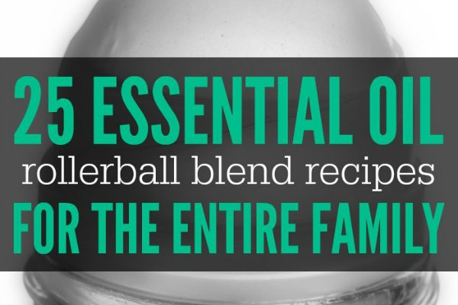

One of the best things about essential oils is their ability to solve common everyday ailments naturally vs taking an over-the-counter medicine. Most of the common items in your medicine cabinet (pain relief, sleep aids, digestive aids, cuts and wounds ointments), can be replaced with a few drops of essential oil.

Depending on the ailment our family is treating, we’ll either…use the oil and apply it directly, apply the oil directly with a carrier oil, or mix the oils together in roller bottles. And that is what I want to share with you…my personal “list” of essential oil rollerball blends & recipes for families.

There are several great things about rollerball bottles. They are premade mixtures – which saves time when something hurts; they are easy to apply – roll it on your feet, your neck, your wrists and you are ready to go; and they stretch out oils, making them last longer by using a carrier oil. (By using a carrier oil, you are not diluting the effectiveness of the oil, you are just giving your oil more coverage with help of something to carry it where you want it to go.)

# Essential Oil Rollerball Blends & Recipes For Families

Here are a couple of things you need to know and purchase before you start making your roller bottles.

* You need 10 mL glass roller bottles. These are [my favorite](http://www.amazon.com/gp/product/B005Y4ZPUW/ref=as_li_tl?ie=UTF8&camp=1789&creative=390957&creativeASIN=B005Y4ZPUW&linkCode=as2&tag=kancitmam-20&linkId=LUAEQOQZWARJLLBY).
* You need a carrier oil. I like (and use) this [avocado oil](http://www.amazon.com/gp/product/B000MGOZ30/ref=as_li_tl?ie=UTF8&camp=1789&creative=390957&creativeASIN=B000MGOZ30&linkCode=as2&tag=kancitmam-20&linkId=6J4B5WB2JCKBNHE3), [fractioned coconut oil](http://www.amazon.com/gp/product/B00NPC7EEU/ref=as_li_tl?ie=UTF8&camp=1789&creative=390957&creativeASIN=B00NPC7EEU&linkCode=as2&tag=kancitmam-20&linkId=GQBOM6SD5DCPW3JM) (my personal favorite) or [almond oil](http://www.amazon.com/gp/product/B0019LVFSU/ref=as_li_tl?ie=UTF8&camp=1789&creative=390957&creativeASIN=B0019LVFSU&linkCode=as2&tag=kancitmam-20&linkId=W6JRYEZC3BPM37AE).
* You need essential oils.
* Optional: [Plastic droppers](http://www.amazon.com/gp/product/B005Z4QVZ4/ref=as_li_tl?ie=UTF8&camp=1789&creative=390957&creativeASIN=B005Z4QVZ4&linkCode=as2&tag=kancitmam-20&linkId=WWXWCUMBAQMUJUI5). I like using these to make up my roller bottles. They are inexpensive and make sure all of the oil gets in the bottle vs on the counter or the outside of the essential oil bottle.

You’ll place the number of drops, per recipe, in a 10 mL rollerball and then fill to the top with your carrier oil of choice. Roll the blends over your neck, feet and wrists (and if applicable, the place that hurts). If there are special instructions, you’ll see them at the end of the recipe. Finally, to be most effective, apply less oil and apply it more often. 

## Essential Oil Rollerball Blends & Recipes for Adults

**stress away blend for mama:**  
18 drops [balance](http://amzn.to/2dmhDpz)  
18 drops [serenity](http://amzn.to/2dmh3s4)  
18 drops [lavender](http://amzn.to/2db3nBk)  
18 drops [grapefruit](http://amzn.to/2db349r) or [citrus bliss](http://amzn.to/2dbfi5P)  
4 drops [wild orange](http://amzn.to/2cX51qn)

**peace & calming blend for mama:**  
6 drops [sandalwood](http://amzn.to/2deK1Lg)  
6 drops [ylang ylang](http://amzn.to/2cFiTCw)  
6 drops [cypress](http://amzn.to/2cFeXlg)  
6 drops [bergamot](http://amzn.to/2dbckhN)  
6 drops [black pepper](http://amzn.to/2deKmNN)

**“grounding” blend for adults:**  
2 drops [patchouli](http://amzn.to/2cFeiAh)  
2 drops [vetiver](http://amzn.to/2cEYZgd)  
2 drops [lime](http://amzn.to/2dvd2WQ)  
20 drops [balance](http://amzn.to/2ddIbM1)  
20 drops [lavender](http://amzn.to/2dbdg5y)

**upset tummy blend for adults:**  
10 drops [peppermint](http://amzn.to/2ddHfYa)  
10 drops [ginger](http://amzn.to/2cP5bkd) (or you can use a pre-made blend like [*digestzen*](http://amzn.to/2dqoJc6))

**sleep blend for adults:**  
4 drops [marjoram](http://amzn.to/2cP4UNT)  
10 drops [frankincense](http://amzn.to/2dqlD7O)  
10 drops [bergamot](http://amzn.to/2cFgGqW)  
12 drops [roman chamomile](http://amzn.to/2dbd7z7)  
12 drops [vetiver](http://amzn.to/2ddIB56)  
15 drops [lavender](http://amzn.to/2cEYT8b)  
10 drops [cedarwood](http://amzn.to/2cEYOkY)

**“liquid morphine” for adults:**  
30 drops [marjoram](http://amzn.to/2dqlwZU)  
30 drops [lemongrass](http://amzn.to/2ddIOp9)  
30 drops [frankincense](http://amzn.to/2dqlbGz)

**aching muscles blend for adults:**  
10 drops [peppermint](http://amzn.to/2cEZ2Zi)  
6 drops [clove](http://amzn.to/2dqlKQG)  
10 drops [wintergreen](http://amzn.to/2cF05Iz)  
6 drops [black pepper](http://amzn.to/2dvfA75)(Massage into achy areas.)

**body aches blend for adults:**  
10 drops [eucalyptus](http://amzn.to/2dveWqt)  
10 drops [lavender](http://amzn.to/2cEYT8b)  
10 drops [deepblue](http://amzn.to/2cEZmal" \t "_blank)

**“wakeup” blend for adults:**  
30 drops lemon  
8 drops [eucalyptus](http://amzn.to/2dveWqt)  
6 drops [peppermint](http://amzn.to/2cEZ2Zi)  
2 drops [cinnamon](http://amzn.to/2dvdZyj)



## Essential Oil Rollerball Blends & Recipes for Kids

**sleep blend for kiddos:**  
15 drops [lavender](http://amzn.to/2cEYT8b)  
10 drops [serenity](http://amzn.to/2d9IJBZ)  
5 drops [roman chamomile](http://amzn.to/2ddKwa0)

**owies blend for cuts, scrapes and bug bites for kiddos:**  
10 drops [lavender](http://amzn.to/2cEYT8b)  
10 drops of [melaleuca](http://amzn.to/2dqmXaM)  
(Apply on effected area.)

**focus on school blend for kiddos:**  
10 drops [peppermint](http://amzn.to/2cEZ2Zi)  
10 drops [wild orange](http://amzn.to/2dbeXA7)



## Essential Oil Rollerball Blends & Recipes for Families

**congestion blend for families:**  
40 drops of [breathe](http://amzn.to/2dqlNfg)  
25 drops of [lime](http://amzn.to/2dbeyxF)  
(Apply over sinus, temples, and ears)

**“flu bomb” for families:**  
10 drops [oregano](http://amzn.to/2cEZfvG)  
18 drops [lemon](http://amzn.to/2ddITcu)  
15 drops [melaleuca](http://amzn.to/2dqmXaM)  
15 drops [onguard](http://amzn.to/2ddIBSS)(Apply on lymph nodes, neck, spine and feet when the flu is spreading or at the first sign of symptoms.)

**headache blend for families:**  
10 drops [frankincense](http://amzn.to/2dqlbGz)  
10 drops [lavender](http://amzn.to/2cEYT8b)  
10 drops [peppermint](http://amzn.to/2cEZ2Zi)

**tension headache blend for families:**  
9 drops [peppermint](http://amzn.to/2cEZ2Zi)  
5 drops [clove](http://amzn.to/2dqlKQG)  
9 drops [wintergreen](http://amzn.to/2cF05Iz)  
6 drops [ginger](http://amzn.to/2ddITJk)

**ADHD blend for families:**  
30 drops [balance](http://amzn.to/2cF0vi2)  
14 drops [patchouli](http://amzn.to/2dbeCx8)  
30 drops [serenity](http://amzn.to/2ddJY3O)  
50 drops [lavender](http://amzn.to/2cEYT8b)  
16 drops [vetiver](http://amzn.to/2ddIB56)

**mental clarity blend for families:**  
8 drops [rosemary](http://amzn.to/2dqn5He)  
12 drops [lemon](http://amzn.to/2ddITcu)  
4 drops [cypress](http://amzn.to/2d9IerI)

**anti-anxiety blend for families:**  
4 drops [frankincense](http://amzn.to/2dqlbGz)  
4 drops [marjoram](http://amzn.to/2dvfQTT)  
6 drops [geranium](http://amzn.to/2ddJ7jI)  
6 drops [clary sage](http://amzn.to/2ddJlHm)  
4 drops [orange](http://amzn.to/2cFin7J)

**motion-sickness for families:**  
16 drops [peppermint](http://amzn.to/2cEZ2Zi)  
16 drops [ginger](http://amzn.to/2ddITJk)  
(Apply to wrists, back of neck and clockwise on tummy.)

**“anti-exhaustion” blend for families:**  
14 drops [eucalyptus](http://amzn.to/2dveWqt)  
10 drops [rosemary](http://amzn.to/2dqn5He)  
6 drops [grapefruit](http://amzn.to/2cEZN4I)

**“bruise blend” for families:**  
20 drops of [lavender](http://amzn.to/2cEYT8b)  
20 drops of [cypress](http://amzn.to/2d9IerI)  
20 drops of [frankincense](http://amzn.to/2dqlbGz)  
(Roll on bruised area.)

**sickness & cold prevention blend for families:**  
10 drops [onguard](http://amzn.to/2dbgoyo" \t "_blank)  
10 drops [oregano](http://amzn.to/2ddKtuF)  
10 drops [lemon](http://amzn.to/2ddITcu)  
(Apply on feet when the flu is spreading or at the first sign of symptoms.)

**seasonal discomfort blend for families:**  
10 drops [lavender](http://amzn.to/2cEYT8b)  
10 drops [lemon](http://amzn.to/2ddITcu)  
10 drops [purify](http://amzn.to/2dqo9e8)  
5 drops [frankincense](http://amzn.to/2dqlbGz)

**allergy blend for families:**  
10 drops [lavender](http://amzn.to/2cEYT8b)  
10 drops [lemon](http://amzn.to/2ddITcu)  
10 drops [peppermint](http://amzn.to/2cEZ2Zi)  
(Apply to bottoms of feet up or back of neck up to 3 times a day.)

Caveat: I’m sharing the 25 Essential Oil Rollerball Blends & Recipes for Families that I’ve made doing my own research, but please make sure to do your own research as well. Everyone’s body is very different and responds differently to different oils. If these blends don’t work for you, there are many other recipes available to use in its place for comfort and relief. Want to know more about essential oils? [Here is my story.](http://redefinedmom.com/how-a-normal-person-uses-essential-oils-in-her-daily-life/)

Like this post? Make sure to follow my [Whole Living Board on Pinterest](https://www.pinterest.com/KellyLSnyder/whole-natural-living/) where I share information about ways to live a more holistic whole life.

Kelly @ Redefined MomWhole Natural LivingFollow On

Disclaimer: These statements have not been evaluated by the Food and Drug Administration. The information on this site is not intended or implied to be a substitute for professional medical advice, diagnosis or treatment. Please confirm any information obtained from or through this web site with other sources, and review all information regarding any medical condition or treatment with your physician. Never disregard professional medical advice or delay seeking medical treatment because of something you have read on this website. This information is not intended to diagnose, treat, or cure any disease.

