* Uses of essential oils – Young Living 2-17
* Under the subheading, “Top Oil Choices for Viruses”:

o   “Top on my list is Thieves. Thieves is highly anti-microbial . . . it could help against Ebola.”

o   “Ebola Virus can not live in the presence of cinnamon bark (this is in Thieves) nor Oregano.” [*sic*]

o   “ImmuPower by Young Living would be a top choice as well. ImmuPower is a blended oil containing (oregano, clove, frankincense, ravintsara, cistus, mountain savory and hyssop). Every single one of these individual oils has anti-viral properties.”

**On the website, www.theoildropper.com, under the heading, “Rosemary Essential Oil by Young Living”:**

* “[R]egular use of rosemary essential oil may . . . help prevent diseases associated with free radicals, including cancer and heart disease.”
* “Rosemary research in regards to Alzheimer’s disease showed aromatherapy as a potential treatment for the cognitive (eg, memory) impairments caused by dementia.”
* “Rosemary . . . has antimicrobial and antiseptic qualities than [*sic*] may help eliminate . . . eczema and dermatitis.”

**On the website, www.theoildropper.com, under the heading, “Myrtle Essential Oil Uses & Benefits”:**

* “Myrtle is a wonderful antiseptic . . . It has been known to protect against tetanus . . ..”
* “Myrtle . . . is also beneficial for other conditions that affect the nerves such as Parkinson’s, Alzheimer’s . . ..”
* “[M]yrtle . . . can help with sexual dysfunction issues such as impotency . . . and ED.”
* “**Cancer protection**…According to a study . . . Myrtle inhibited prostate and breast cancer cells along with Sandalwood at very low concentrations. Sandalwood essential oil ranked number one for inhibiting growth of breast cancer at 98.1% and Myrtle was at 95.2%.”

**On the website, www.theoilessentials.com, under the heading, “Are you panicked about the Ebola Virus after watching the news this week?”:**

* “[T]he Ebola virus cannot survive in the presence of a therapeutic grade Cinnamon Bark and Oregano essential oil.”

**On the website, www.theoilessentials.com, under the heading, “Young Living August 2014 Monthly Promotion”:**

* Under the subheading, “Young Living Eucalyptus Blue essential oil”:

o   “Eucalyptus Blue essential oil has antiviral and anti-inflammatory properties.”

* Under the subheading, “Young Living Peppermint Essential Oil”:

o   “Peppermint oil has so many more uses . . . asthma, autism, brain injury . . . Crohn’s disease . . . multiple sclerosis, paralysis . . ..”

**On the website, www.theoilessentials.com, under the heading, “Young Living July 2014 Monthly Promotion”:**

* Under the subheading, “Ylang Ylang Essential Oil”:

o   “Ylang Ylang is used medicinally . . . for the treatment of . . . arterial hypertension . . . diabetes . . . insomnia, heart palpitations, and tachycardia.”

**On the website, http://essentialsurvival.org, under the heading, “Essential Oils & More to Combat Ebola Virus”:**

* Under the subheading, “My Essential Oil Picks for Ebola”:

o   “The most potent anti-viral essential oils that I have in my arsenal are **Thieves**, **ImmuPower** . . ..”

o   “**Thieves** oil is a blend of cinnamon, rosemary, clove, eucalyptus, and lemon oils that has been shown in university studies to obliterate bacteria and viruses, as well as mold . . ..”

o   “**Thieves oil can be . . . applied topically on the skin to help the body fight off infection** . . . If Ebola was going around in my area . . . I would apply it to my feet and armpits 2x/day or more and take it in capsules at least 2x/day for preventive purposes.”

o   “If I were exposed to Ebola or had reason to believe I could be sick with it, I would **use some of these oils every 10 minutes for a few hours, then cut back to every hour for the rest of the first day**. Then I would use them every 2 waking hours of the day for at least a week, or longer if it was known I was sick.”

**On the website, http://essentialsurvival.org, under the heading, “Frankincense – Medicine for Wise Men & Women”:**

* Under the subheading, “Frankincense Cancer Research”:

o   “Research shows that components of frankincense oil called boswellic acids have an anti-tumor effect on the following types of cancer cells, causing them to implode . . . Prostate cancer cells . . . Colon cancer cells . . . Cervical cancer cells . . . Bladder cancer cells . . . Leukemia cells . . . Melanoma and fibrosarcoma cells . . . Brain tumor cells.”

o   “Boswellic acids also appear promising to help with **multiple myeloma**, and have general **anti-cancer properties**.”

* Under the subheading, “In summary, **frankincense oil**”:

o   “Is toxic only to cancer cells (unlike chemotherapy that kills healthy cells too) . . . Causes cancer cells to implode through ‘apoptosis’, the best way for cancer cells to go . . . Shrinks tumors in preliminary research with animals . . . Helps the body heal from all types of cancer in clinical data . . . Helps to prevent cancer – using it appears to lower risk of cancer . . ..

[](http://www.youngliving.com/)

**Young Living Blog**

* [Home](http://www.youngliving.com/blog/)
* [Recipes](https://www.youngliving.com/blog/category/recipes/)
* [DIY](https://www.youngliving.com/blog/category/diy/)
* [Mind & Spirit](https://www.youngliving.com/blog/category/mind-spirit/)
* [Healthy & Fit](https://www.youngliving.com/blog/category/healthy-fit/)
* [Infographics](https://www.youngliving.com/blog/category/infographics/)
* [At Home](https://www.youngliving.com/blog/category/at-home/)
* [Archive](https://www.youngliving.com/blog/category/archive/)
* [Videos](https://www.youngliving.com/blog/category/videos/)
* [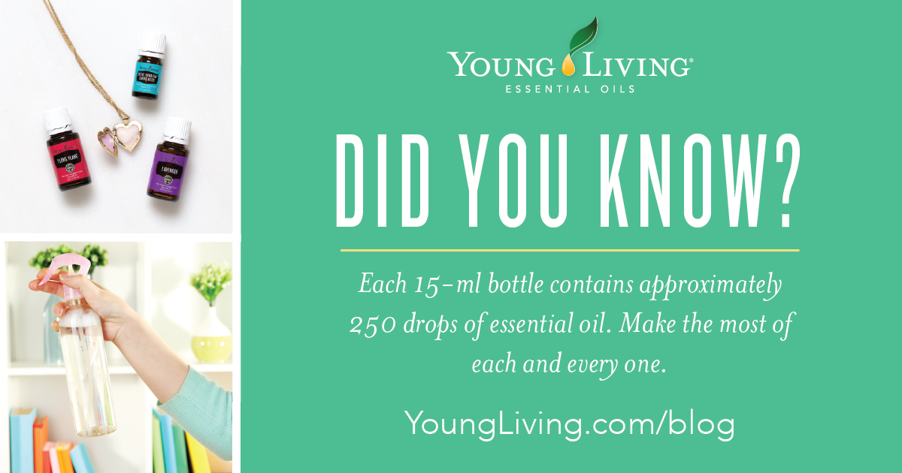](https://www.youngliving.com/blog/wp-content/uploads/2016/05/Blog-Whats-your-essential-oil-IQ_Header_US_0316_AH__Micrographic_US-1.png)

**What Can You Do with a 15-ml Bottle of EO?**

54 May 4, 2016 - [Aromatherapy](https://www.youngliving.com/blog/category/aromatherapy/), [At Home](https://www.youngliving.com/blog/category/at-home/), [Cleaning with Young Living](https://www.youngliving.com/blog/category/cleaning-with-young-living/), [DIY](https://www.youngliving.com/blog/category/diy/), [Essential Oils](https://www.youngliving.com/blog/category/essential-oils/), [How to Use Essential Oils](https://www.youngliving.com/blog/category/usingessentialoils/), [Infographics](https://www.youngliving.com/blog/category/infographics/), [Personal Care](https://www.youngliving.com/blog/category/personal-care/), [Skin care](https://www.youngliving.com/blog/category/skin-care-2/), [Young Living Lifestyle](https://www.youngliving.com/blog/category/young-living-lifestyle/), [Young Living Personal Care](https://www.youngliving.com/blog/category/young-living-personal-care/)

[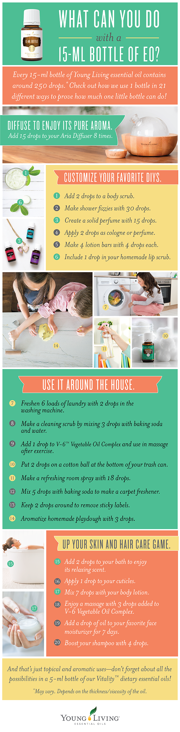](https://www.youngliving.com/blog/wp-content/uploads/2016/05/15ml-bottle-uses-infographic-blog-02.png)**Did we forget any of your favorite uses? Let us know some of your ideas in the comments!**

[15-ml Bottle Uses](https://www.youngliving.com/blog/tag/15-ml-bottle-uses/)[Cleaning](https://www.youngliving.com/blog/tag/cleaning/)[DIY](https://www.youngliving.com/blog/tag/diy/)[Essential Oils](https://www.youngliving.com/blog/tag/essential-oils/)[hair care](https://www.youngliving.com/blog/tag/hair-care/)[laundry](https://www.youngliving.com/blog/tag/laundry/)[massage](https://www.youngliving.com/blog/tag/massage/)[skin care](https://www.youngliving.com/blog/tag/skin-care/)[Tips](https://www.youngliving.com/blog/tag/tips/)

https://www.youngliving.com/blog/wp-content/themes/inspire-yl-child/images/share-plus-blank.pngShare

* [LINE it!](http://line.me/R/msg/text/?What%20Can%20You%20Do%20with%20a%2015-ml%20Bottle%20of%20EO?%0D%0Ahttps://www.youngliving.com/blog/what-can-you-do-with-a-15-ml-bottle-of-eo/)
* 1K+

**28 Comments**

• https://secure.gravatar.com/avatar/847a79e665efbf62d5e5450fe9bc58a4?s=50&d=mm&r=g

Karen Smith January 14, 2017 - 2:00 am [Reply](https://www.youngliving.com/blog/what-can-you-do-with-a-15-ml-bottle-of-eo/?replytocom=125776#respond)

Using it on a vacuum cleaner bag makes the house smell wonderful.

• https://secure.gravatar.com/avatar/ec9f2af6a9c37b604b1aba08a14a1433?s=50&d=mm&r=g

Nikki Kopmann January 4, 2017 - 10:24 am [Reply](https://www.youngliving.com/blog/what-can-you-do-with-a-15-ml-bottle-of-eo/?replytocom=122460#respond)

Can you post a specific recipe for bath fizzes and body scrub? Thanks!

• https://secure.gravatar.com/avatar/86f9facf3f8ba3e67cdf60bffb2088f2?s=50&d=mm&r=g

Jill October 13, 2016 - 7:10 am [Reply](https://www.youngliving.com/blog/what-can-you-do-with-a-15-ml-bottle-of-eo/?replytocom=95315#respond)

You people are crazy to ingestion and use topically without dilution

• https://secure.gravatar.com/avatar/af5ceb042a3cf7f09d8dbcde5d816e56?s=50&d=mm&r=g

Laurie August 20, 2016 - 11:45 pm [Reply](https://www.youngliving.com/blog/what-can-you-do-with-a-15-ml-bottle-of-eo/?replytocom=86268#respond)

Is there a quick reference guide/list of which oils are available in the 15ml size?

* https://secure.gravatar.com/avatar/1317154208b9ded2789f31d3165b4d62?s=50&d=mm&r=g

Young Living August 29, 2016 - 7:20 am [Reply](https://www.youngliving.com/blog/what-can-you-do-with-a-15-ml-bottle-of-eo/?replytocom=87938#respond)

Hi Laurie, At this time, we do not have a comprehensive list of the oils available in the 15ml bottle. However each of our oils are listed in the Product Guide and online with the sizes available. Thanks for stopping by!

• https://secure.gravatar.com/avatar/c088485f128af35b3a20e4046263d96b?s=50&d=mm&r=g

Kim Olin August 18, 2016 - 11:54 pm [Reply](https://www.youngliving.com/blog/what-can-you-do-with-a-15-ml-bottle-of-eo/?replytocom=86051#respond)

3 drops of peppermint on a cotton ball in a tiny zip lock type baggie (found at crafting stores), close. When having nausea and vomiting, open baggie & sniff several times.

• https://secure.gravatar.com/avatar/31f27a0957b847c463a587dd40cdce37?s=50&d=mm&r=g

Maru July 18, 2016 - 2:45 pm [Reply](https://www.youngliving.com/blog/what-can-you-do-with-a-15-ml-bottle-of-eo/?replytocom=80544#respond)

How many drops in a 5ml?

* https://secure.gravatar.com/avatar/1317154208b9ded2789f31d3165b4d62?s=50&d=mm&r=g

Young Living July 18, 2016 - 3:02 pm [Reply](https://www.youngliving.com/blog/what-can-you-do-with-a-15-ml-bottle-of-eo/?replytocom=80545#respond)

Hi Maru, Great question! There are approximately 85 drops (1 teaspoon) in a 5 ml bottle.

• https://secure.gravatar.com/avatar/7fe0f18dc810417d0ed9d14855752f78?s=50&d=mm&r=g

Denise Mychele Hutchinson June 1, 2016 - 3:51 am [Reply](https://www.youngliving.com/blog/what-can-you-do-with-a-15-ml-bottle-of-eo/?replytocom=74790#respond)

I make the best Swedish Meatballs ever now that I have YLEO! And I share the empty bottles with Blends for Friends in need with the roller attachment.

* https://secure.gravatar.com/avatar/5ad827a6c612b812073e17148294af1e?s=50&d=mm&r=g

Robin Colyer August 19, 2016 - 8:34 am [Reply](https://www.youngliving.com/blog/what-can-you-do-with-a-15-ml-bottle-of-eo/?replytocom=86082#respond)

What oils do you use for them? Would you post your recipe please?

• https://secure.gravatar.com/avatar/92c92c2c1170215f2fa54e987e0d39d3?s=50&d=mm&r=g

Carmen Ayala May 15, 2016 - 10:48 am [Reply](https://www.youngliving.com/blog/what-can-you-do-with-a-15-ml-bottle-of-eo/?replytocom=71359#respond)

Easy as 1, 2, 3,  
One drop on my DIY necklace diffuser  
Two drops on my DIY car diffuser  
Three drops on my personal carry diffuser

• https://secure.gravatar.com/avatar/c64df9213103090256f623ab0d75f79a?s=50&d=mm&r=g

Stephanie Hammel May 13, 2016 - 9:39 am [Reply](https://www.youngliving.com/blog/what-can-you-do-with-a-15-ml-bottle-of-eo/?replytocom=70946#respond)

I play Roller Derby and my gear bag can get a little smelly, so I use a few drops of Purification and Joy on cotton balls in a mesh bag inside the gear bag and it keeps it a little more fresh.

• https://secure.gravatar.com/avatar/198dcecf8686ddc79f28fe7f2c586a2a?s=50&d=mm&r=g

[Jessica](https://richaromas.com/) May 11, 2016 - 6:56 am [Reply](https://www.youngliving.com/blog/what-can-you-do-with-a-15-ml-bottle-of-eo/?replytocom=70357#respond)

Great post. Like you said there are so many uses for essential oils and lots of things to do with just one bottle. However the amount of oil used also depends greatly on the the type of diffuser it’s being used in.

• https://secure.gravatar.com/avatar/834b2e7dd25f18735a59e48ca2f810dd?s=50&d=mm&r=g

Cheryl May 6, 2016 - 1:37 pm [Reply](https://www.youngliving.com/blog/what-can-you-do-with-a-15-ml-bottle-of-eo/?replytocom=69334#respond)

One drop of any Vitality EO with my toothpaste every morning and night. Very refreshing!

• https://secure.gravatar.com/avatar/4231f63ec2ded327c31c07f025cbd40c?s=50&d=mm&r=g

[Esther](https://www.instagram.com/esther_stigter/) May 6, 2016 - 10:28 am [Reply](https://www.youngliving.com/blog/what-can-you-do-with-a-15-ml-bottle-of-eo/?replytocom=69292#respond)

I add 1-2 drops of Grapefruit and 1-2 drops of Tea Tree oil to my facial lotion/moisturizer! Thank you Y.L.

• https://secure.gravatar.com/avatar/f64cb7c1b3be2ca83d941e9ad33d8b22?s=50&d=mm&r=g

Bethany May 6, 2016 - 7:32 am [Reply](https://www.youngliving.com/blog/what-can-you-do-with-a-15-ml-bottle-of-eo/?replytocom=69269#respond)

My favorite snack right now is Plain Greek Yogurt with added vanilla stevia drop and a few lemon vitality essential oil drops! It tastes like a lemon mousse but much better for you!

• https://secure.gravatar.com/avatar/e78e697030923fe5f538a39c7456e1f4?s=50&d=mm&r=g

Georgia piekart May 6, 2016 - 3:54 am [Reply](https://www.youngliving.com/blog/what-can-you-do-with-a-15-ml-bottle-of-eo/?replytocom=69245#respond)

I put 3 drops of peppermint in distilled water and make an awesome room freshener spray

* https://secure.gravatar.com/avatar/c8cb5247c9200e324d0e29c372998cd0?s=50&d=mm&r=g

Ava Marie September 23, 2016 - 9:19 am [Reply](https://www.youngliving.com/blog/what-can-you-do-with-a-15-ml-bottle-of-eo/?replytocom=92189#respond)

Hi Georgia, I also put 2-4 drops of peppermint, lavender or purification oil on cotton balls or flat cotton pads and put them in my air vent to make my car smell good, the past owner was a smoker and this is so refreshing and keeps me awake on long drives. Take Care.

• https://secure.gravatar.com/avatar/55be05eb890d678fe421fe74aa57a5bc?s=50&d=mm&r=g

Jayne May 6, 2016 - 12:10 am [Reply](https://www.youngliving.com/blog/what-can-you-do-with-a-15-ml-bottle-of-eo/?replytocom=69222#respond)

I add 2 drops of vitality oils to my homemade tarter sauce when having fish.

• https://secure.gravatar.com/avatar/aa7085f07af36693f30c6abec0ae3ace?s=50&d=mm&r=g

Sue Bon3 May 5, 2016 - 8:58 pm [Reply](https://www.youngliving.com/blog/what-can-you-do-with-a-15-ml-bottle-of-eo/?replytocom=69207#respond)

Three drops of a vitality essential oil to a bottle of water! Always a refreshing drink anytime of the day. I’m not a water drinker, but with the lemon vitality, I drink twice as much water. So refreshing.

• https://secure.gravatar.com/avatar/4b0d52c8a7b327df91d274565bfc2344?s=50&d=mm&r=g

Angelic Sexton May 5, 2016 - 8:36 pm [Reply](https://www.youngliving.com/blog/what-can-you-do-with-a-15-ml-bottle-of-eo/?replytocom=69205#respond)

Love these ideas! Thank you 🙂

* https://secure.gravatar.com/avatar/e2d6cc4c93456a69fce25897ba8f50b5?s=50&d=mm&r=g

Sandy Miller September 27, 2016 - 10:38 am [Reply](https://www.youngliving.com/blog/what-can-you-do-with-a-15-ml-bottle-of-eo/?replytocom=92717#respond)

Me too Angelic! Thanks to everyone expressing their experience with EO.

• https://secure.gravatar.com/avatar/14bcff638652319f55a7d49c737de9b8?s=50&d=mm&r=g

[Jodi Green](http://essentialoilobsessed.com) May 5, 2016 - 7:54 pm [Reply](https://www.youngliving.com/blog/what-can-you-do-with-a-15-ml-bottle-of-eo/?replytocom=69199#respond)

Put 3 drops on a cotton ball and leave in sneakers overnight. Put a few drops on the inside of a toilet paper roll. Close tissues in an airtight container with a cotton ball and 3 drops of essential oils. So many uses!

* https://secure.gravatar.com/avatar/d11f849a501d8fd2c81430f489cfa273?s=50&d=mm&r=g

marji groth May 12, 2016 - 9:20 pm [Reply](https://www.youngliving.com/blog/what-can-you-do-with-a-15-ml-bottle-of-eo/?replytocom=70827#respond)

I never thought of either of these ideas! Thank you!

* https://secure.gravatar.com/avatar/9a62728864fcb25ec82dba74333023dd?s=50&d=mm&r=g

Janina May 17, 2016 - 6:56 pm [Reply](https://www.youngliving.com/blog/what-can-you-do-with-a-15-ml-bottle-of-eo/?replytocom=71795#respond)

Love it! I have put a couple drops for the smelly shoe, didn’t think about the toilet paper roll! Thanks for that one!

* https://secure.gravatar.com/avatar/778c83d8a0b3cf6ea7b80435c3a40f27?s=50&d=mm&r=g

Michelle Brenmark July 13, 2016 - 11:30 am [Reply](https://www.youngliving.com/blog/what-can-you-do-with-a-15-ml-bottle-of-eo/?replytocom=79920#respond)

Awesome tips Jodi! Thanks for sharing! 🙂

• https://secure.gravatar.com/avatar/11c6168338a9745c270333b136bbb1a0?s=50&d=mm&r=g

Kat May 5, 2016 - 3:43 am [Reply](https://www.youngliving.com/blog/what-can-you-do-with-a-15-ml-bottle-of-eo/?replytocom=69084#respond)

I added a few drops of lemon vitality EO to my home made drinks! Delightful!

• https://secure.gravatar.com/avatar/dc3b6880c8728f2d9cd1f7ec24a54836?s=50&d=mm&r=g

Lisa hansen May 4, 2016 - 5:57 pm [Reply](https://www.youngliving.com/blog/what-can-you-do-with-a-15-ml-bottle-of-eo/?replytocom=69034#respond)

Love the oils.

**Leave a reply**

Top of Form



Name * 

Email * 

Website 

Bottom of Form

Top of Form

Bottom of Form

*\* Please note that all comments are moderated and won't appear immediately. Additionally, some posts may be slightly modified or deleted to maintain compliance with Young Living’s Policies and Procedures and federal regulations. To ensure your comments are compliant, please refer to the* [*Sharing Young Living the Right Way*](https://static.youngliving.com/en-US/PDFS/sharing_yl.pdf) *document.*

**Never miss a blog post!**

Top of Form

Email Address Name Email Frequency

Bottom of Form

Top of Form

Bottom of Form

**Search**

Top of Form



Bottom of Form

**Other Posts You Might Like**

[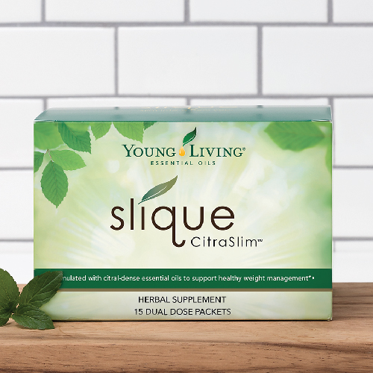](https://www.youngliving.com/blog/slique-citraslim-study/)

[**The Results Are In: See How Slique CitraSlim Measures Up! [Infographic]**](https://www.youngliving.com/blog/slique-citraslim-study/)

[We put Slique CitraSlim to the test, and the results are in! See what participants have to say about this new supplement.](https://www.youngliving.com/blog/slique-citraslim-study/)

5 December 19, 2016 [13](https://www.youngliving.com/blog/slique-citraslim-study/#comments)

[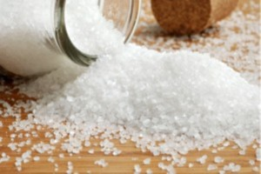](https://www.youngliving.com/blog/make-and-take-party-diy-holiday-gifts-theme/)

[**Make and Take Party: DIY Holiday Gifts Theme**](https://www.youngliving.com/blog/make-and-take-party-diy-holiday-gifts-theme/)

[Thinking about making homemade holiday gifts using essential oils? Invite your friends over for a make-and-take party! At a recent Monthly Education Seminar, Young Living member and party-hosting expert Nance Ciasca not only taught us how to have a successful make-and-take party but also gave us ideas on a "Holiday Gifts" party theme.](https://www.youngliving.com/blog/make-and-take-party-diy-holiday-gifts-theme/)

29 November 8, 2014 [23](https://www.youngliving.com/blog/make-and-take-party-diy-holiday-gifts-theme/#comments)

**Tag Cloud**

[blend](https://www.youngliving.com/blog/tag/blend/) [Blue Agave](https://www.youngliving.com/blog/tag/blue-agave/) [cinnamon](https://www.youngliving.com/blog/tag/cinnamon/) [Cinnamon Bark Essential Oil](https://www.youngliving.com/blog/tag/cinnamon-bark-essential-oil/) [clove](https://www.youngliving.com/blog/tag/clove/) [convention](https://www.youngliving.com/blog/tag/convention/) [D. Gary Young](https://www.youngliving.com/blog/tag/d-gary-young/) [day](https://www.youngliving.com/blog/tag/day/) [DIY](https://www.youngliving.com/blog/tag/diy/) [Essential](https://www.youngliving.com/blog/tag/essential/) [essential oil](https://www.youngliving.com/blog/tag/essential-oil/) [Essential Oil Recipes](https://www.youngliving.com/blog/tag/essential-oil-recipes/) [Essential Oils](https://www.youngliving.com/blog/tag/essential-oils/) [Frankincense](https://www.youngliving.com/blog/tag/frankincense/) [frankincense essential oil](https://www.youngliving.com/blog/tag/frankincense-essential-oil/) [Gary Young](https://www.youngliving.com/blog/tag/gary-young/) [Lavender](https://www.youngliving.com/blog/tag/lavender/) [lavender essential oil](https://www.youngliving.com/blog/tag/lavender-essential-oil/) [lemon](https://www.youngliving.com/blog/tag/lemon/) [Lemon essential oil](https://www.youngliving.com/blog/tag/lemon-essential-oil/) [Manager](https://www.youngliving.com/blog/tag/manager/) [NingXia Nitro](https://www.youngliving.com/blog/tag/ningxia-nitro/) [NingXia Red](https://www.youngliving.com/blog/tag/ningxia-red/) [Nutrition](https://www.youngliving.com/blog/tag/nutrition/) [oil](https://www.youngliving.com/blog/tag/oil/) [Orange](https://www.youngliving.com/blog/tag/orange/) [Orange Essential Oil](https://www.youngliving.com/blog/tag/orange-essential-oil/) [Peppermint](https://www.youngliving.com/blog/tag/peppermint/) [Peppermint Essential Oil](https://www.youngliving.com/blog/tag/peppermint-essential-oil/) [Product](https://www.youngliving.com/blog/tag/product/) [Product Manager](https://www.youngliving.com/blog/tag/product-manager/) [recipe](https://www.youngliving.com/blog/tag/recipe/) [Seed to Seal](https://www.youngliving.com/blog/tag/seed-to-seal/) [skin care](https://www.youngliving.com/blog/tag/skin-care/) [Slique](https://www.youngliving.com/blog/tag/slique/) [Stress Away](https://www.youngliving.com/blog/tag/stress-away/) [Therapeutic-Grade Essential Oils](https://www.youngliving.com/blog/tag/therapeutic-grade-essential-oils/) [Thieves](https://www.youngliving.com/blog/tag/thieves/) [Thieves Essential Oil Blend](https://www.youngliving.com/blog/tag/thieves-essential-oil-blend/) [Thieves Household Cleaner](https://www.youngliving.com/blog/tag/thieves-household-cleaner/) [time](https://www.youngliving.com/blog/tag/time/) [Young](https://www.youngliving.com/blog/tag/young/) [Young Living](https://www.youngliving.com/blog/tag/young-living/) [Young Living Essential Oils](https://www.youngliving.com/blog/tag/young-living-essential-oils/) [Young Living Therapeutic Grade](https://www.youngliving.com/blog/tag/young-living-therapeutic-grade/)

COPYRIGHT (C) 2016 - ALL RIGHTS RESERVED - YOUNG LIVING

POWERED BY WORDPRESS, DEVELOPED BY BOOSTDEVELOPERS

https://www.youngliving.com/blog/wp-content/themes/inspire/images/footer-toggle.png

Save