Re: MMS2 Preparation (Jim Humble)

OK, I've gone ahead and purchased Calcium Hypochlorite and even ingested a capsule, and I've been communicating with Jim Humble about all this, so I'll share with you all my journey so far.
First, I searched on the web, found a local chemical distributor of Calcium Hypochlorite, and purchased a 2kg drum of the substance, for the equivalent of something like US$12.
The label says it's "CALCIUM HYPOCHLORITE GRANULAR 70%", and that it is "a Calcium compound containing 70% available Chrlorine. It is a multipurpose bleaching agent, disinfectant and bactericide. The economic and efficient properties maintain hygienic conditions in most situation such as water treatment, swimming pool care and industrial (laundry, textile, livestock etc.)."
It also has 2 labels which say "OXIDIZING" and "CORROSIVE".
This is what it looks like with the drum opened:
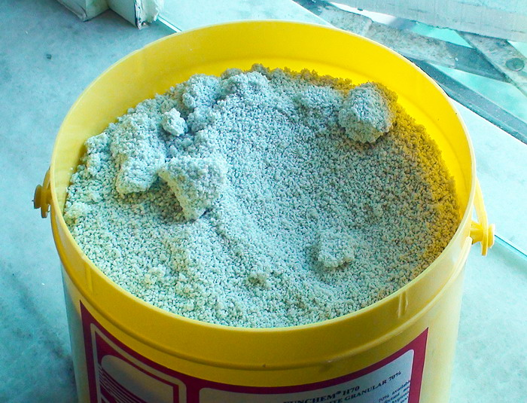
The first thing I noticed was that it has a VERY VERY STRONG smell. A bit like chlorine, and simply quite nauseating. It was so strong that even before opening the SEALED drum, if you take a sniff around the lid, you could smell it. Once you open it, you get the full impact of it, which is quite bad. You think MMS1 smells bad? Wait till you try this! I put on a mask which made it a bit better.
Actually let me rephrase. The smell itself is not that bad (possibly better than MMS1), but what makes it so bad is how STRONG the smell is. It's very over-powering. If anyone tries this, I suggest you do it outdoors.
I then scooped the substance into the Size 0 capsules that I purchased separately. The first time I scooped 4 pills (didn't really touch the substance much), and the next thing I noticed was that my fingers had a bit of a sticky texture. I tried to wash it off with soap, but my fingers continued to have that sticky feeling for a while. The next time I tried it, I just used disposable gloves to handle it.
This is what the pills look like, with the calcium hypochlorite inside:
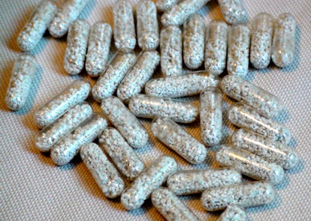
3 of us popped a pill each yesterday, and I'm happy to report that we are still alive.
Swallowing the pill was very easy, and you don't get much of the smell at all, so in this respect it is MUCH better than MMS1.
HOWEVER, after about 30 minutes, all 3 of us started getting small burps, and that's when we could smell/taste the substance again. The burps continued over the next couple or so hours, once every 15 minutes or so, and it was not very pleasant. Not too bad (we could continue functioning), but it's something we'd definitely prefer avoiding.
I think the next time I try it, I would take it along with a meal, or eat a chocolate bar along with it or something.
[EDIT - WE HADN'T REALIZED THAT WE SHOULD HAVE TAKEN THE MMS2 CAPSULES WITH 2 GLASSES OF WATER (WHAT JIM RECOMMENDS), WHICH WOULD HAVE PREVENTED ANY BURPING. SEE MY LATER POST BELOW.]
Apart from that, we didn't feel anything negative - no stomach cramps, nausea, diarrhea or things like that. None of us had any problems/illness so can't really say whether it did us any good (and in any case, 1 capsule wont' be enough).
During this process, I have also been communicating with Jim Humble. Jim told me / confirmed to me the following:
1. Yes, the label description sounds about right.
2. Yes, it smells terrible.
3. Yes, it makes your hand sticky.
4. Yes, it's meant to be granular (I thought it was more like fine powder looking at the pics in his mms2 page), and granular is what he's always used.
5. Like me, he takes the long end of the capsule and dips it into the substance to scoop it up until it is full before closing it with the short end.
6. For cancer, take 4 capsules a day (one every 2 hours), plus MMS1 every hour.
7. For general maintenance, take 1 capsule a day.
8. For cold/flu, take 1 capsule with 2 glasses of water in the first hour. Then take 1/2 capsule (open capsule and dump out 1/2 and then put the lid back on) with 1 glass of water every hour until the cold is gone or the flu is gone.
That last point about cold also seems to suggest that we should be taking the capsules with a LOT of water, which ties in with what he is saying about how calcium hypochlorite turns into hypochlorous acid when in contact with water.
When we swallowed that one pill, we just took it with a sip of water. So PERHAPS there may have been less burping if we had taken lots of water with it?
Anyway, that's my experience with MMS2 so far. My advice for anyone trying this:
1. Put on a face mask
2. Put on disposable gloves
3. Get a capsule container ready to put in all the capsules
4. Do it outdoors
5. Take it with a meal
6. Take lots of water with the capsules (2 glasses the first time, and 1 glass the following ones in the day if taking every hour.)
Hope that helps! And hope to hear from others who have also tried it so we can compare notes!

