
T. J. Clark Contact Information
 | T. J. Clark  1145 North 1100 West  St. George, UT 84770  USA  Order Line: 1-800-228-0872  Information and International Calls.  1-435-634-0309  Fax Line: 1-435-634-0308  Customer Service Department  Private Label and Custom Formulations  Small Business Opportunity | 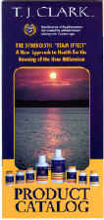  Request a T. J. Clark  Product and Price List.
Bottom of Form
Also www. tjclark.co.nz - tyrosine, colloidal minerals

