**Dona Mary Dirlam, M.S. G.G. F.G.A. GIA Library Director**

**http://www.gia.edu/gia-news-research-GIA-innovators-dirlam**

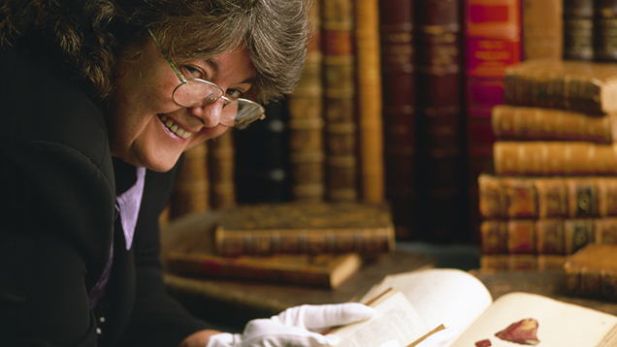

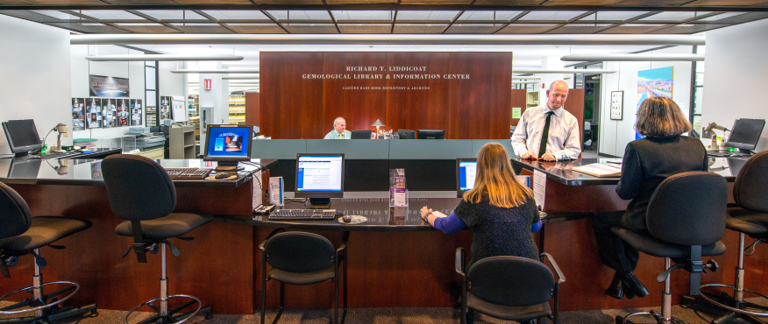

Dona Dirlam’s playthings of choice growing up in Minnesota were a collection of Oregon agates. Pursuing this hobby led to a master’s degree in geology and geophysics and a position as a geology and earth science teacher in Madison, Wisconsin. Yet her interest in gems never wavered, and when she heard about GIA’s degree programs, she moved to Santa Monica to pursue her GG. Thus began a lifelong affiliation between Dirlam and GIA that has changed the face of the Institute’s library and research resources.  
   
Upon completion of her GG in 1979, Dirlam was encouraged by [Dr. Vincent Manson](http://www.gia.edu/gia-news-research-GIA-innovators-manson) to work as a diamond grader until a position in research became available. While she waited, she made such use of the Institute’s library that she caught the attention of [Richard Liddicoat](http://www.gia.edu/gia-news-research-GIA-innovators-liddicoat), who was seeking someone with a background in gemology, geology and teaching to revamp the Institute’s library. He found a willing and able candidate in Dirlam, who assumed her new responsibilities as GIA’s librarian in July 1980. Since December 1995, she has been director of the Richard T. Liddicoat Gemological Library and Information Center, which under her leadership became the world’s largest and most prestigious library of its kind.  
   
Among Dirlam’s successes during her tenure with the Institute were the 1987 acquisition of the 14,000-volume [John & Marjorie Sinkankas Gemological Library](http://www.gia.edu/gems-gemology/spring-1989-sinkankas-library-dirlam), a negotiation that took four years to complete. She tirelessly lectured on gemological subjects and served as abstracts editor of Gems & Gemology from 1981 to 1994. She also serves as the secretary of the Geo-Literary Society. To date, Dirlam has also coauthored 11 articles for the journal, five of which received a G&G Most Valuable Article award. Her contributions to both GIA and the field of gemology led to widespread accolades, including the 1989 Outstanding Gemologist Award from the Association of Women Gemologists and GIA’s Staff of the Year in 1991. GIA selected her for its highest honor, the Richard T. Liddicoat Distinguished Achievement Award, in 2004.  
   
Under Dirlam’s 34-year leadership, the library has expanded from a 2,000-book installation to a state-of-the-art facility. Over 16,000 books and 1,800 videos are in circulation, along with CD-ROMs, audio CDs, and subscriptions to over 230 periodicals in numerous languages, with access provided to students, staff, and the general public. The Cartier Archives and Rare Book Repository Collections, which houses the Sinkankas collection, has expanded from an initial 14,000 books to 41,000 resources. The Visual Resources Library, also maintained by the Carlsbad library, contains over 143,000 images and assets to enhance the Institute’s course and publication materials. Dona Dirlam’s groundbreaking efforts on behalf of the Institute’s research, education, and outreach capabilities have kept GIA at the forefront of gemological scholarship.