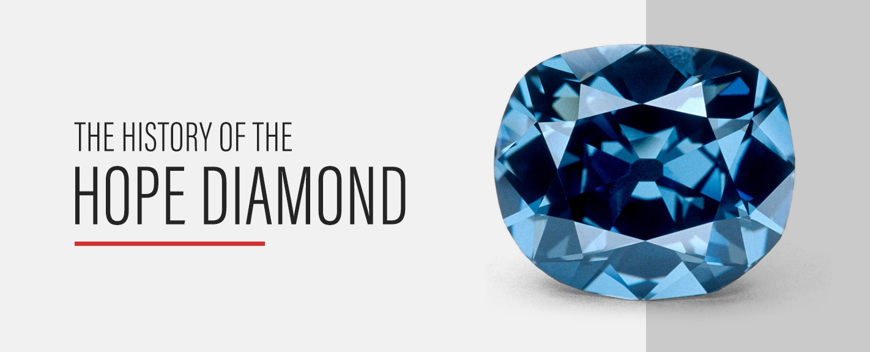

**The History of the Hope Diamond, Fortuna**

in [Discover](https://www.fortunaauction.com/category/discover/) / [Jewelry](https://www.fortunaauction.com/category/jewelry/)

Diamonds are one of the most prominent physical representations of wealth and value you can find. Crafted through very long-term natural processes, they often appear in imagery associated with the wealthiest of the wealthy, frequently even signifying royalty.

Easily one of the most recognizable diamonds in the world is the Hope Diamond, estimated to be worth roughly a quarter of a billion dollars. On top of its incredible beauty, the Hope Diamond carries an illustrious history that contributes significantly to its great value.

**Where Did It Originate?**

Though most of the Hope Diamond’s notable history occurred in the past few centuries, its origins reach back over a billion years, when it was formed under immense pressure [deep beneath the Earth’s crust](https://www.livescience.com/hope-cullinan-diamonds-deep-origins.html). It was then borne to the surface by volcanic activity, where it remained for millions of years.

The diamond first entered human history sometime in the seventeenth century, when it was discovered at a mine in India. The exact location is uncertain, though it was most likely the Kollur mine in Golkonda. At some point after its discovery, it passed into the hands of a traveling French merchant named Jean-Baptiste Tavernier, who brought it with him back to Europe.

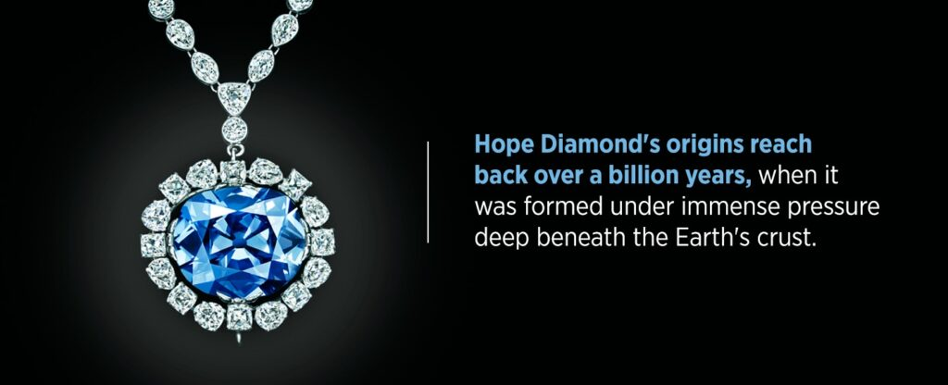

**Who Owned It?**

Perhaps the most fascinating element of the diamond’s history comes down to the number of remarkable historical figures who have owned it. Beginning the day Tavernier sold it, the Hope Diamond made a name for itself in large part due simply to the fame and fortune of those figures, and the way it changed hands between them.

**A Royal Heirloom**

The first figure to acquire the diamond, purchasing it from Tavernier in 1668, was King Louis XIV of France. As an unbelievably wealthy and extravagant ruler, Louis had the diamond recut and made into one of his crown jewels.

Upon Louis’s death, the diamond passed to his son and grandson, finally settling on Louis XVI. This Louis, along with his wife, Marie Antoinette, were beheaded during the French Revolution. The subsequent looting of the royal treasuries caused the diamond to be lost for several years.

When it resurfaced again in 1812, it was in the hands of a diamond merchant in London named Daniel Eliason, who eventually sold it to yet another king — this time, King George IV of the United Kingdom.

**A Family Name**

Upon George’s death, the diamond was most likely sold to pay off debt incurred during his reign, and by 1839 it had made its way to well-known collector Henry Philip Hope, from whom it got its name.

After Hope’s death, the diamond passed to his nephew, Henry Thomas, and then to Henry Thomas’s grandson, Lord Francis Hope. When Lord Francis eventually sold it in 1901 to pay off his debts, it went through a series of jewel merchants. Lord Francis sold it to a local dealer in London, who sold it to Joseph Frankels in New York City, who sold it to Selim Habib, who sold it to C.H. Rosenau.

**A Social Symbol**

Rosenau finally [sold the gem to Pierre Cartier](https://www.forbes.com/sites/forbesdigitalcovers/2019/12/06/secret-history-hope-diamond-the-cartiers-book-excerpt/#37ade6117bed), the acclaimed jeweler in Paris. Cartier had little interest in passing the diamond to another merchant, instead, turning his eye to the supply of wealthy American socialites. He found his ideal target in Evalyn Walsh McLean, the heiress to a multimillionaire who literally struck gold working as a miner.

McLean was fascinated with diamonds and other gems, so Cartier made every effort to sell her the Hope Diamond. After a few failed attempts, he succeeded in persuading her by leaving the diamond in her hands for a week, long enough for her to become attached to it. Then, following a frustratingly long process, McLean finally purchased the diamond in 1911 and maintained ownership of it for the rest of her life.

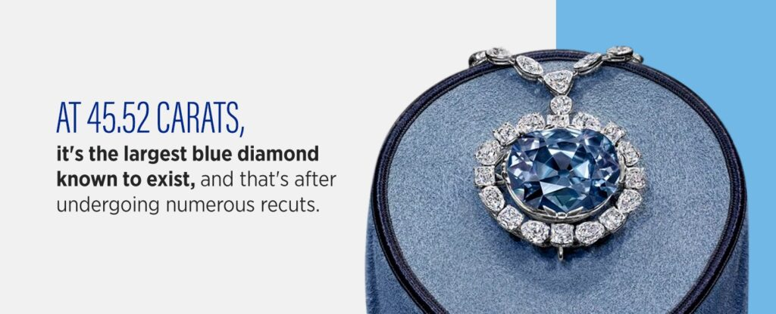

When McLean died in 1949, wealthy American jeweler Harry Winston purchased the diamond. After spending just under a decade putting the diamond on display around the country, he generously donated the stone to the Smithsonian Institute in 1958.

**Why Is It So Special?**

Much of the Hope Diamond’s value stems from its remarkable history, and from all the impressive figures who have possessed it over the centuries. But its history isn’t the only quality that makes it valuable — after all, it had no history at all when it was sold to Louis XIV, and yet surely it must have had great value to attract the interest of a man styling himself “the Sun King.”

The most visible source of the diamond’s value is its sheer beauty. Covered in countless facets, it holds a deep blue color all the way through—due to trace elements of boron in the stone. It is also classified as a Type IIb diamond, the rarest of natural diamonds which possess incredibly low levels of nitrogen impurities and phosphoresces, emitting a red glow when exposed to ultraviolet light.

Natural blue diamonds are incredibly rare to begin with, and most of them are neither as bold or as large as the Hope Diamond. At [45.52 carats](https://www.si.edu/spotlight/hope-diamond), it’s the largest blue diamond known to exist, and that’s after undergoing numerous recuts. In its original form, it was recorded as being 112 carats.

Finally, the diamond carries an element of intrigue due to the misfortune it’s been historically rumored to bring. Much like with Tutankhamen’s tomb, many of the people associated with it have suffered from a run of bad luck, from Louis XVI’s execution to the [deaths of Evalyn McLean’s children](https://naturalhistory2.si.edu/mineralsciences/hope/details/the-misfortunes-of-evalyn-walsh-mclean.htm). Even figures like McLean herself were attracted to the diamond due in part to this intrigue.

**Where Is It Today?**

The Hope Diamond has been in the possession of the Smithsonian Institute since it was gifted by Harry Winston. It’s kept on display in the Smithsonian National Museum of Natural History in Washington, D.C., at the forefront of the gem collection. Locked safely in a display case, it’s kept rotating slowly on its pedestal for visitors to look at and admire.