[Daily Cover](https://www.forbes.com/daily-cover-stories)|Dec 6, 2019,04:00pm EST|40,258 views

**The Secret History Of The Hope Diamond: How Pierre Cartier Sold A Cursed Jewel**

[**https://www.forbes.com/sites/forbesdigitalcovers/2019/12/06/secret-history-hope-diamond-the-cartiers-book-excerpt/?sh=39438c577bed**](https://www.forbes.com/sites/forbesdigitalcovers/2019/12/06/secret-history-hope-diamond-the-cartiers-book-excerpt/?sh=39438c577bed)

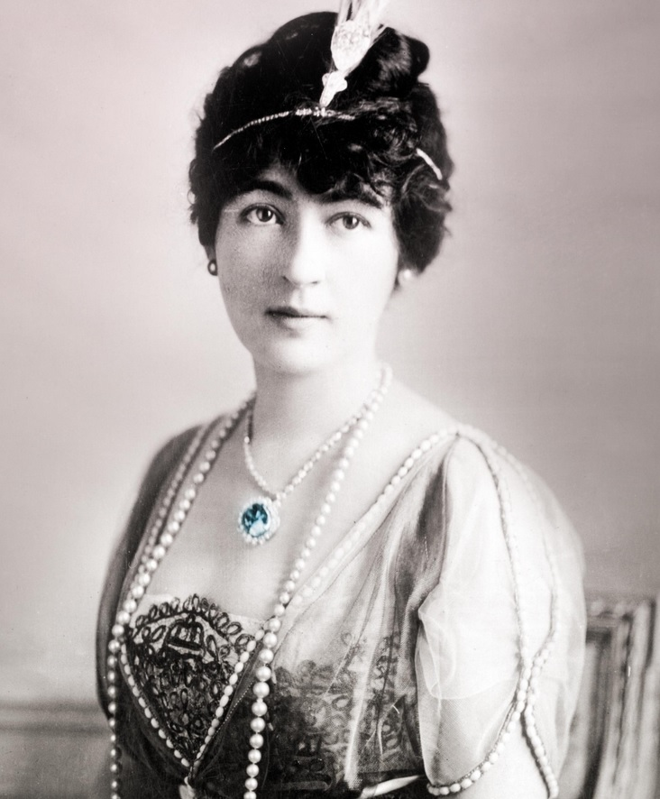

[](https://www.forbes.com/sites/forbesdigitalcovers/)

[Francesca Cartier Brickell](https://www.forbes.com/sites/forbesdigitalcovers/people/francescacartierbrickell/)

Contributor

[Forbes Digital Covers](https://www.forbes.com/sites/forbesdigitalcovers/)

Contributor Group

[Business](https://www.forbes.com/business)

#### • • An excerpt from T​he Cartiers​ by Francesca Cartier Brickell

A**s ever more** **prestigious clients** rolled into his New York boutique at the turn of the 20th Century, Pierre Cartier [grandson of Louis-Francois Cartier, founder of the eponymous jewelry brand] was insistent that the firm remain true to its original aim: “We must never lose our current reputation; in other words, we must sell only large jewels.”

It was with this in mind that, in 1910, he invested in a gemstone so large and important that it represented an enormous risk. If he couldn’t sell it, Cartier would be left with a dent in its cash flow that could severely hamper the entire firm. And yet Pierre was in no doubt that it was a risk worth taking. As he had discovered in America, the fame and size of one’s diamond was everything.

Sometimes jewels carry a story with them that impacts all their owners. The notoriously cursed 45-carat blue Hope Diamond, once known as the Tavernier Blue, was one of these. Since its discovery in the Kollur mine in seventeenth-century India by Jean-Baptiste Tavernier, a French gem merchant, many of those who had owned or even been close to the stone were said to have suffered terrible fates. [Its uplifting name is derived from the London banking family that owned the gem in the 1830s.]

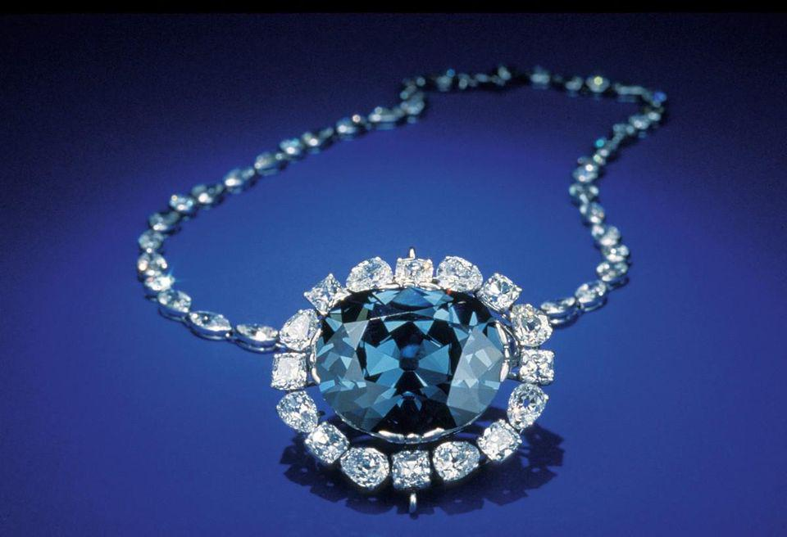

Gem Fatale: The notorious Hope Diamond on display at the Smithsonian, where it has resided since 1958.

Reuters

If you were to believe the stories, the horrific endings linked to it included being torn apart by wild dogs in Constantinople, being shot onstage and, in the case of Marie Antoinette and Louis XVI (who had enjoyed the diamond as part of the French crown jewels), famously being beheaded during the French Revolution.

Several months after Pierre opened Cartier’s New York branch, the company bought the Hope Diamond in Paris. The gemstone had changed hands several times in the preceding few months. From Simon Frankel, a diamond dealer in New York, it had passed to a collector in Turkey (reportedly on behalf of Sultan Hamid of the Ottoman Empire before he was deposed), and then on to the French dealer Rosenau, from whom Cartier acquired it for 500,000 francs (around $2.2 million today). Though the gem was magnificent, it was not easy to locate a client who was wealthy enough to afford it, fanatical enough about diamonds to need a large blue one, and brave enough to disregard the curse. Frankel, for example, hadn’t been able to find a buyer for seven years, after which time his finances were in such a dire strait that he was forced to sell it at a distressed price.

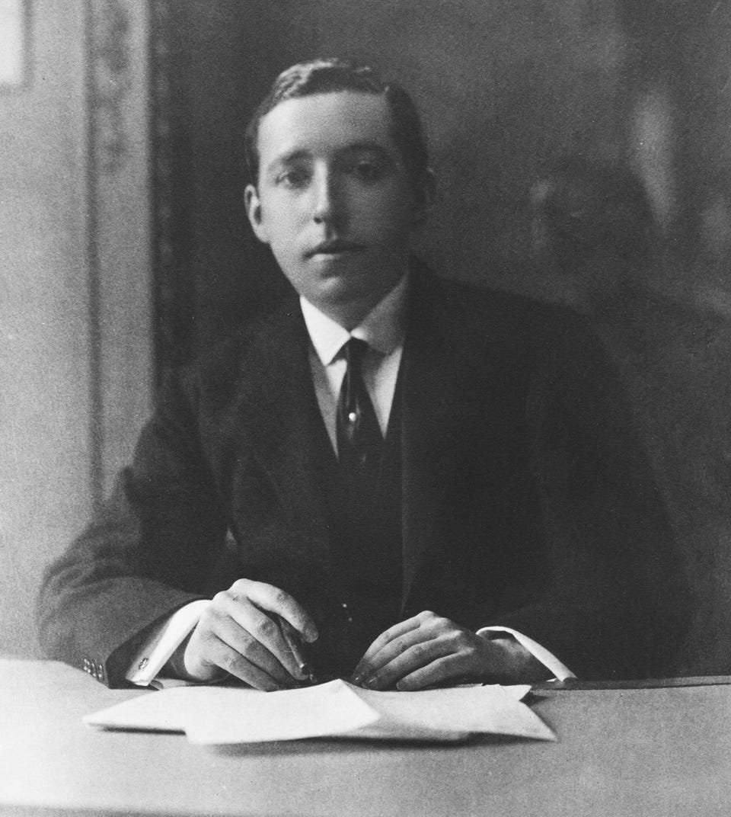

Diamond Dealer in the Rough: A young Pierre Cartier.

Courtesy of Francesca Cartier Brickell

This was where Cartier, with its multiple branches and increasingly impressive global client list, started to come into its own. Pierre and his brothers, Jacques and Louis, could be hot on the buying scene in Paris, where so many of the best gemstones came to market, while simultaneously discreetly spreading the word of their new purchase overseas. They were well aware that an American heiress would relish the idea of parading a unique jewel from the chic French capital in front of her peers back home. In the case of the Hope Diamond, the brothers were confident enough of selling it that they were not to be deterred by the 1908 warnings in the press: “There are those who say [diamond dealers] will never regain their old position of supremacy in their trade as long as the Hope Diamond remains in their ownership.” In fact, far from being put off by the curse, Pierre believed the gemstone’s notoriety could act in his favor. He even had a client in mind who he suspected would be enticed by it.

The American heiress Evalyn Walsh McLean couldn’t get enough of jewels. She was inordinately rich, thanks to her father, who had literally struck gold with one of the largest gold mines in America. In 1908, at the age of twenty-two, Evalyn married nineteen-year-old Ned McLean of the well-known Washington Post family. The young couple, it was widely reported, had far more money than sense. “It is no use to anyone to chide me for loving jewels. I cannot help it if I have a passion for them,” Evalyn admitted. “They make me feel comfortable, and even happy. The truth is, when I neglect to wear jewels, astute members of my family call in doctors because it is a sign I’m becoming ill.”

Evalyn had previously crossed paths with the Cartiers in 1908 when she was on her honeymoon in Paris. Two years later, when Evalyn and Ned were back in the French capital, Pierre made an appointment to meet them in their hotel. Understanding from their previous purchases that the jewelry they sought out was large and significant, he was hopeful they would fall on the Hope Diamond like hungry wolves. “His manner was exquisitely mysterious,” Evalyn remembered, as he placed an intriguing-looking package sealed with wax seals before them. Pierre retraced the gemstone’s famous history for his captive audience, from its prominent place among the French crown jewels for more than a century, to a London lord and a Turkish sultan, and now all the way to their very hotel room in Paris. By the time he unveiled the gemstone, he had them on the edge of their seats. Unfortunately, though, it wasn’t enough. Whether it was because the young couple weren’t keen on the setting, or they had misgivings about the curse, or they had simply run out of that kind of spending money by the end of their trip that year, Evalyn and Ned left empty-handed.

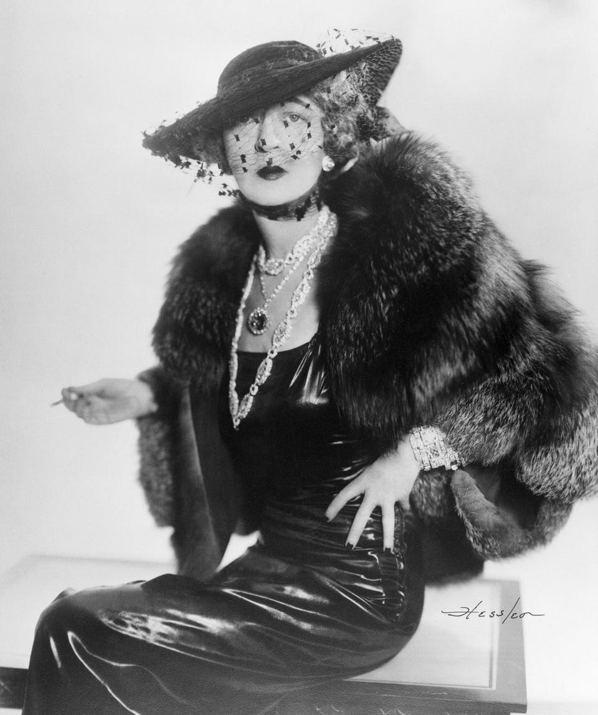

Rock Star: Glamorous socialite Evalyn Walsh McLean wearing the Hope Diamond.

Bettmann Archive

Disappointed but determined his instincts were right about the McLeans being the perfect clients for the Hope, Pierre moved on to Plan B. He shipped the gemstone to America and changed the setting to an oval frame of smaller diamonds that enhanced the large blue Hope in the center. He again showed it to Evalyn, who, though more interested this time around, was still not convinced. Knowing his client’s weakness for gems, Pierre proposed that she hold on to the necklace for a few days, suspecting that once she had it in her possession, it would be almost impossible for her to return it. She was used to getting things, not to giving them back. Evalyn took the bait and that evening, before she went to bed, she placed the diamond on her dresser. “For hours, that jewel stared at me, and at some time during the night I began to really want the thing. Then I put the chain around my neck and hooked my life to its destiny for good or evil.”

The next day, Pierre received word that the McLeans would buy the Hope. The price was $180,000 (about $5 million today), of which the first installment was to be $40,000.

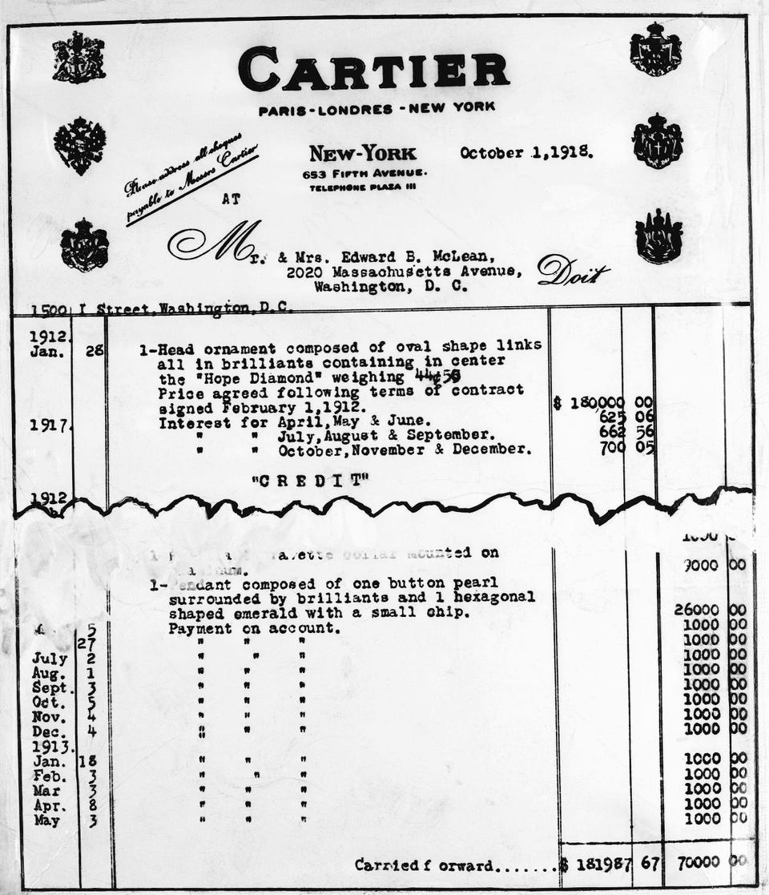

Point of No Return: The bill for the Hope Diamond, which Cartier sold to the McLeans for $180,000 in 1912.

Associated Press

The Cartiers were relieved: Having large gemstones in stock played havoc with the firm’s cash flow until they were sold. But as with many privileged clients, the sale process wasn’t as straightforward as it might have been. Several weeks after the agreed contract had been signed and the McLeans had taken possession of the gemstone, Pierre hadn’t yet received a cent in payment. At his clients’ request, he had even put a clause into the contract to assuage their worst curse-related fears (the “customer’s privilege to exchange goods in case of fatality”), but still Evalyn procrastinated. At one stage, she tried sending the Hope back to Cartier. Pierre refused to stand for it and the necklace was returned to its owner along with a repeat demand for payment. By March 1911, two months after the sale had been agreed upon, Pierre was so frustrated by his clients’ endless delaying tactics that a series of exchanges with Louis in Paris led the brothers to file a legal suit against the McLeans.

Finally realizing that there was no legal way out of the deal, Evalyn changed tack and decided that if she was going to buy the gemstone, she should at least take it to church for a blessing. She wasn’t sure she believed in the curse, but May Yohe, the ex-wife of Thomas Hope and a previous wearer of the diamond, had publicly warned her against it in a March 1911 newspaper article, and she couldn’t help but be spooked. The blessing took place in the church of Russel Monseigneur. The diamond was awaiting its blessing on a velvet cushion, when seemingly on cue, lightning flashed and thunder shook the building. Many might have taken this as a sign to back away, but not Evalyn. “Ever since that day,” she would later declare, “I’ve worn my diamond as a charm.” The sale was finally concluded in early 1912, with the McLeans trading in the emerald from the Star of the East pendant they had bought a couple of years earlier to help pay for the Hope.

Financially speaking, the sale of the Hope wasn’t a positive for Cartier. After all the legal fees, the firm ended up taking a loss. The board meeting minutes noted, “Upon examining our legal expenses . . . we have decided to be more strict. In future, we will have to think very carefully before taking legal advice. We will avoid it as much as possible.” And yet there was no question in Pierre’s mind that it had been worth it. Through this single transaction, Cartier became a household name in New York. After all, who wasn’t secretly fascinated by the exploits of the opulent and profligate McLeans? Add to that the idea of a mysterious curse, and the gossip columns had struck gold. The Cartiers may have shied away from taking out advertisements in the early years (Louis particularly felt they were beneath a great jewelry maison favored by royalty), but they were more than happy to have their name spread by the press alongside pictures or social updates of their famous clients. And Evalyn McLean, who loved the stone’s notoriety, never missed an opportunity to flaunt the spectacular Hope. She tied the diamond around the neck of her Great Dane dog, Mike, or held lavish garden parties where she hid it in the bushes and insisted the guests join in her favorite game: Find the Hope.

Evalyn held on to the diamond for the rest of her life, and though she never believed in the curse, she suffered a fair amount of bad luck over the years. Her husband, Ned, ran off with another woman and later died in a mental institution; their family paper, The Washington Post, went bankrupt; her son was killed in a car accident; and her daughter died of a drug overdose.

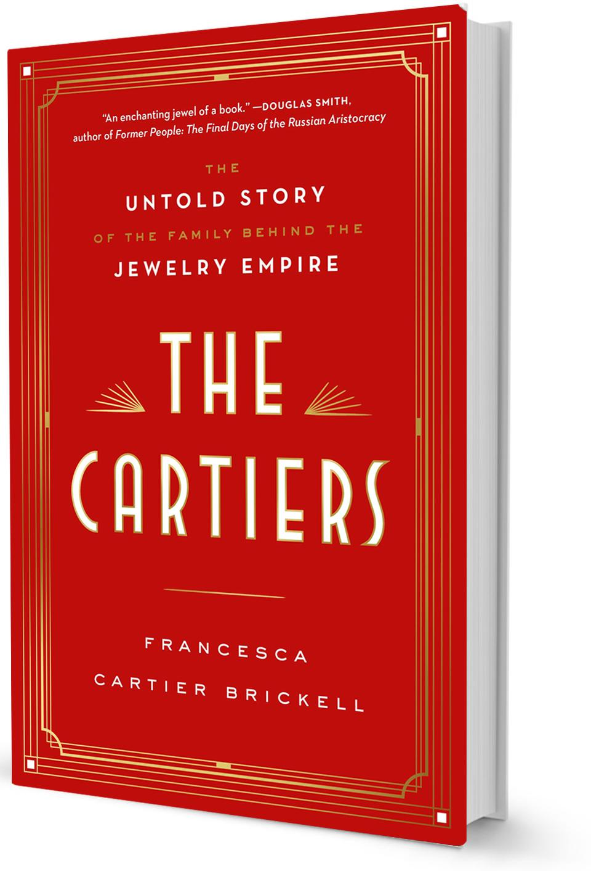

Penguin Random House

And for a brief moment during the Depression, she was forced to pawn the Hope Diamond for $37,500 in a last-minute attempt to prevent a house foreclosure. On the day she had arranged to reclaim it, she took the train from Washington to New York and turned up at William Simpson’s pawnshop entirely alone. No bodyguard for her, in fact not even a bag: She stuffed the diamond, along with a few other precious stones she was picking up, into her dress and set off uptown to meet some friends. After lingering too long over lunch, she rushed to catch her train, running “through the station so fast I thought I would be shaking the stones out of my bosom at every step.” A far cry from the high security of the Smithsonian Institution, where the Hope sits safely on a turntable within a glass cabinet today, attracting more than seven million visitors a year and currently estimated to be worth around $350 million.