Manuscript
Original Appraisal of Crown Jewels of Charles I, taken 10 Jun, 1629

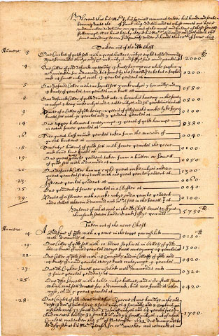
www.lhconklin.com\lhconklin\www.lhconklin.com\gallery\charles.htm

Manuscript. Original Appraisal of Crown Jewels of Charles I, taken 10 Jun, 1629.
This is a manuscript appraisal (approximately one folio sized sheet folded into four pages, written on two) dated June 10, 1629, of certain crown jewels pledged by Charles I and subsequently sold by him. The appraisal was made, and signed, by the following gentlemen— James Herriot, Phillipe Jacobsson, Thomas Sympson and William Tirrey all jewelers of London.
In 1629 the King removed the contents of the Secret Jewel House in the Tower to Whitehall Palace, and inspected them himself on June 5. He took away seven pieces. Sixteen more went into the custody of the Gentleman of the Robes, and an additional twenty-six pieces were pledged to a Groom of the Bedchamber, James Maxwell. The remaining fifty-two pieces were to be sold. This inventory list comprises the twenty-six pieces which were pledged to Maxwell and sold to him in January of 1630 for £12554, the sum at which they were valued the previous June.
This incident is described in detail by A.J. Collins, Jewels and Plate of Queen Elizabeth I, 1955, pp. 178, 179.
This valuation list gives no date in June for the King’s warrant to the jewellers. It was, in fact, issued after the valuation was made, on June 20, judging from Calendar of State Papers Domestic 1628-9, pp. 583, 584. A list of the jewels is printed in Rymer, Foedra VIII, part III, 1742, pp. 90-91, but it is not identical with this list.
One of the most interesting elements of this document are the jewelers’ comments on “diamonds” which they state are something else (see nos. 4 & 25.) The items bought by Maxwell included ornaments which James I had designated, in 1605, for preservation as heirlooms, e.g. the circlet of gold for Queen Anne (new chest, no. 28) and the collar of 12 pieces of goldsmith’s work “lyke fryers knotts” (old chest, no. 9). In fact, Maxwell acquired more than one third of the heirlooms.
This historic document may well be unique. I remember once reading a book, whose title I cannot now recall, that stated that inventories of crown jewels of Charles I are not known to exist!
The following is a transcription of a small part of the first page of the appraisal–
Whereas that his Matie by his speciall warrant under his hand and seale bearing date the [blank] of June 1629: did com~ande us whose names are heire underwritten to deliver our opinons of the worth and valewe of these Jewells ffollowinge, wee have heirby obeyid his Maties commande and delivererid the same according to our Judgments under or hands this 20th of June 1629
Taiken out of the olde chestt
Numors:
.3. One Circlett of gold sett with a great ballace rubye eight table diamonds nyne emraulds thirtye and sixe wth rubyis and fiftye sixe round pearles at £2000.
.4. One Coller of gold de____ conteyn~ng 13 knotts havinge one white saphir wch was taken for a diamond, but found by the Jewellers to be but a saphir.... 0200.
Price on Request.

