Jean-Baptiste Tavernier 1605 –1689

http://en.wikipedia.org/wiki/Jean-Baptiste_Tavernier

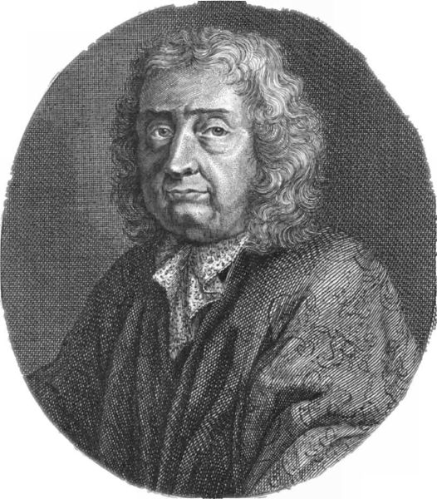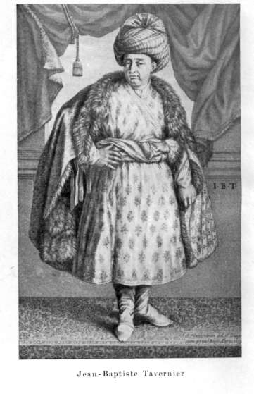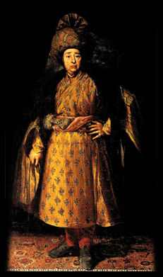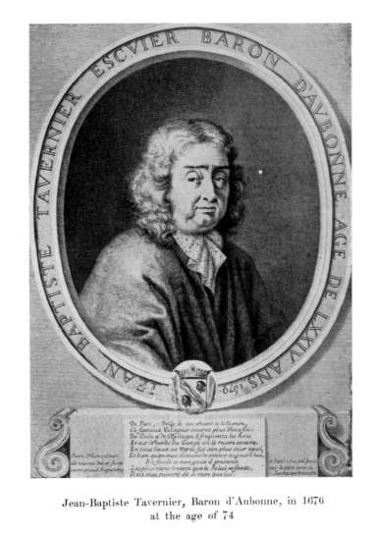

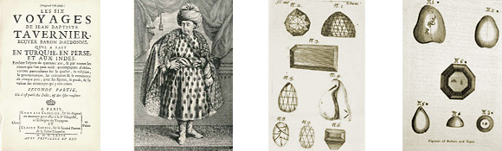

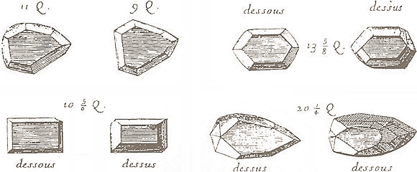

Jean-Baptiste Tavernier (1605 – July 1689), French traveller and pioneer of trade with India, was born in 1605 at Paris, where his father Gabriel and uncle Melchior, Protestants from Antwerp, pursued the profession of geographers and engravers.
The conversations he heard in his father's house inspired Tavernier with an early desire to travel, and in his sixteenth year he had already visited England, the Low Countries and Germany, and seen something of war with the imperialist Colonel Hans Brenner, whom he met at Nuremberg. Four and a half years in the household of Brenner's uncle, the viceroy of Hungary (1624-29), and a briefer connection in 1629 with the duke of Rethel and his father the duke of Nevers, prince of Mantua, gave him the habit of courts, which was invaluable to him in later years; and at the defence of Mantua in 1629, and in Germany in the following year with Colonel Walter Butler (afterwards notorious through the death of Wallenstein), he gained some military experience.
When he left Butler to view the diet of Ratisbon in 1630, he had seen Italy, Switzerland, Germany, Poland and Hungary, as well as France, England and the Low Countries, and spoke the principal languages of these countries. He was now eager to visit the East; and at Ratisbon he found the opportunity to join two French fathers, M. de Chapes and M. de St Liebau, who had received a mission to the Levant. In their company he reached Constantinople early in 1631, where he spent eleven months, and then proceeded by Tokat, Erzerum and Erivan to Persia. His farthest point in this first journey was Isfahan; he returned by Baghdad, Aleppo, Alexandretta, Malta and Italy, and was again in Paris in 1633.
Of the next five years of his life nothing is known with certainty, but it was probably during this period that he became controller of the household of the duke of Orleans. In September 1638 he began a second journey (1638-43) by Aleppo to Persia, and thence to India as far as Agra and Golkonda. His visit to the court of the Great Mogul and to the diamond mines was connected with the plans realized more fully in his later voyages, in which Tavernier travelled as a merchant of the highest rank, trading in costly jewels and other precious wares, and finding his chief customers among the greatest princes of the East. The second journey was followed by four others. In his third (1643-49) he went as far as Java, and returned by the Cape; but his relations with the Dutch proved not wholly satisfactory, and a long lawsuit on his return yielded but imperfect redress.
In his last three journeys (1651-55, 1657-62, 1664-68) he did not proceed beyond India. The details of these voyages are often obscure; but they completed an extraordinary knowledge of the routes of overland Eastern trade, and brought the now famous merchant into close and friendly communication with the greatest Oriental potentates. They also secured for him a large fortune and great reputation at home. He was presented to Louis XIV, in whose service he had travelled sixty thousand leagues by land, received letters of nobility (on the 16th of February 1669), and in the following year purchased the barony of Aubonne, near Geneva. In 1662 he had married Madeleine Goisse, daughter of a Parisian jeweller.
Thus settled in ease and affluence, Tavernier occupied himself, as it would seem at the desire of the king, in publishing the account of his journeys. He had neither the equipment nor the tastes of a scientific traveller, but in all that referred to commerce his knowledge was vast and could not fail to be of much public service. He set to work therefore with the aid of Samuel Chappuzeau, a French Protestant littérateur, and produced a Nouvelle Relation de l'Intérieur du Sérail du Grand Seigneur (4to, Paris, 1675), based on two visits to Constantinople in his first and sixth journeys.
This was followed by Le Six Voyages de J. B. Tavernier (2 vols. 4to, Paris, 1676) and by a supplementary Recueil de Plusieurs Relations (4to, Paris, 1679), in which he was assisted by a certain La Chapelle. This last contains an account of Japan, gathered from merchants and others, and one of Tongking, derived from the observations of his brother Daniel, who had shared his second voyage and settled at Batavia; it contained also a violent attack on the agents of the Dutch East India Company, at whose hands Tavernier had suffered more than one wrong. This attack was elaborately answered in Dutch by H. van Quellenburgh (Vindicfie Batavicae, Amst., 2684), but made more noise because Arnauld drew from it some material unfavourable to Protestantism for his Apologie pour les Catholiques (1681), and so brought on the traveller a ferocious onslaught in Jurieu's Esprit de M. Arnauld (2684). Tavernier made no reply to Jurieu; he was in fact engaged in weightier matters, for in 1684 he travelled to Berlin at the invitation of the Great Elector, who commissioned him to organize an Eastern trading company--a project never realized.
The closing years of Tavernier's life are obscure; the time was not favorable for a Protestant, and it has even been supposed that he passed some time in the Bastille. This, however, has been shown to be highly improbable by Tavernier's biographer Charles Joret. What is certain is that he left Paris for Switzerland in 1687, that in 1689 he passed through Copenhagen on his way to Persia through Russia, and that in the same year he died at Moscow. It appears that he had still business relations in the East; but the true reason for the final journey of this indefatigable old man remains a mystery.
Tavernier's travels, though often reprinted and translated, have a defect: the narrative is much confused by his plan of often deserting the chronological order and giving instead notes from various journeys about certain routes. It is true that this defect, while it makes the biographer's task more difficult, is hardly a blemish in view of the object of the writer, who sought mainly to furnish a guide to other merchants. A careful attempt to disentangle the thread of a life still in many parts obscure has been made by Charles Joret, Jean-Baptiste Tavernier d'aprés des Documents Nouveaux, 8vo, Paris, 1886, where the literature of the subject is fully given. See also an English translation of Tavernier's account of his travels so far as relating to India, by V Ball, 2 vols. (1889).
For the 400th anniversary of Tavernier’s birth in 2005, the Swiss filmmaker Philippe Nicolet made a full-length film about him called Les voyages en Orient du Baron d’Aubonne. Another Swiss, the sculptor Jacques Basler, has made a life-sized bronze effigy of the great 17th-century traveller which looks out over Lake Geneva at Chexbres.

References
- This article incorporates text from the Encyclopædia Britannica Eleventh Edition, a publication now in the public domain.

External links
- Describing Tavernier's travels in India, including his trade in gems, diamonds and visits to Maharadja's Tavernier: Travels in India (English Translation), Oxford University Press, Humphrey Milford, Translated by Ball, London 1925.
- Tavernier part II + appendices on Koh-I-Noor, diamonds and diamond and gold mining. Both Volumes translated from Le Six Voyages de J. B. Tavernier (2 vols. 4to, Paris, 1676)
========================================================================================================================
END

