BILL GATES’ WEB OF DARK MONEY AND INFLUENCE – PART 1: PHILANTHROPIC NARRATIVE SHAPING

[11 COMMENTS](https://thelastamericanvagabond.com/top-news/bill-gates-web-dark-money-influence-part-1-philanthropic-narrative-shaping/)

https://secureservercdn.net/50.62.194.30/cm2.2c3.myftpupload.com/wp-content/themes/hades/images/clock.png 23 MAY 2020  https://secureservercdn.net/50.62.194.30/cm2.2c3.myftpupload.com/wp-content/themes/hades/images/author.png POSTED BY DERRICK BROZE

[](https://thelastamericanvagabond.com/top-news/bill-gates-web-dark-money-influence-part-1-philanthropic-narrative-shaping/)

1 Star2 Stars3 Stars4 Stars5 Stars

In the first few months of 2020, business tycoon and billionaire Bill Gates saw his popularity soar through the roof. According to [YouGov](https://today.yougov.com/topics/politics/explore/public_figure/Bill_Gates), 58 percent of Americans polled about Gates had a positive opinion of him, he is equally liked by men and women, and both Boomers and Millennials adore him. Gates’ popularity might have increased due to a viral Netflix documentary about his life being released in late 2019. Combine that positive press with a wave of media interviews seeking the guidance of the man who “[predicted](https://www.latimes.com/entertainment-arts/story/2020-04-13/coronavirus-bill-gates-ellen-degeneres-ted-talk)” the next major pandemic, and voila – *Bill Gates is a superhero here to save the planet from impending doom.*

Of course, this rather cartoonish view ignores several incontrovertible facts, and a few strong theories regarding Gates’ true intentions. First, the facts. Bill Gates has used his immense wealth to garner influence and media time, spreading his message of fixing global health issues while he continues to make billions. Using the Bill and Melinda Gates Foundation to dole out grants and donations, Gates has created a web of organizations who owe their budget to the foundation or answer directly to Gates. By tracing the Foundation’s investments and Gates’ relationships we can see that nearly every person involved in the fight against COVID-19 is tied to Gates or his foundation [by two degrees or less](https://exploringyourmind.com/the-six-degrees-of-separation-theory/). This gives Bill Gates and his foundation an unchallenged influence over the response to the pandemic. Equally worrisome is Gates’ call for global lock down until the entire world has been vaccinated and given a digital certificate to prove immunity.

Now, the theories: when taking a careful listen to several speeches and statements made by Gates, it becomes clear that he has a penchant for discussing reducing population growth. Despite “fact checkers” claiming Gates’ words have been taken out of context, his words speak for themselves. He believes the population should be reduced or prevented from growing, and he believes this can be done with vaccines and healthcare.

As we attempt to peel back the layers of PR stunts and [puff pieces](https://www.nytimes.com/2020/05/22/opinion/bill-gates-coronavirus.html) fawning over Bill Gates, we hope to illustrate that the man being propped up on the global stage and sold to the people as their savior, is anything but. Despite the apparent growth in support for Bill Gates, there is also evidence on social media that people are beginning to question him and challenge the savior narrative. This is the first step in unraveling**Bill Gates’ Web of Dark Money and Manipulation.**

THE GLOBAL INFLUENCE OF THE BILL AND MELINDA GATES FOUNDATION

In 1994, the story goes, Bill Gates asked his father, William Gates Sr., to help him “improve reproductive and child health” by founding and leading the William H. Gates Foundation. Gates Sr. agreed and by 2000, the Foundation was merged with the Gates Learning Foundation to become the Bill & Melinda Gates Foundation. According to the Foundation, Bill Gates has [donated $36 billion](https://www.gatesfoundation.org/who-we-are/general-information/foundation-faq) of his personal wealth to the foundation. The Foundation is estimated to be valued at $46.8 billion.

For the last two decades the Foundation has invested in a range of controversial companies and projects while pursuing their goal of improving global health and access to vaccines and reproductive care. This has all been done as part of Gates’ plan to reshape his public image as that of a friendly and kind billionaire whose only aim is to help the world. The reality is much more suspect.

Let’s take, for example, the Netflix documentary mentioned above,*Inside Bill’s Brain: Decoding Bill Gates*. Rather than being a genuine look at the life and personality of Gates, the documentary failed to acknowledge conflicts of interest which might portray the film – and Bill Gates – in a different light. In a recent explosive investigation examining the reach of Gates’ money, *The Nation* noted that, *“in the first episode, director Davis Guggenheim underlines Gates’s expansive intellect by interviewing Bernie Noe, described as a friend of Gates.”* Noe goes on to tell of Gates reading 150 pages an hour with 90 percent retention. However, *The Nation* reported, *“Guggenheim doesn’t tell audiences that Noe is the principal of Lakeside School, a private institution to which the Bill & Melinda Gates Foundation has given $80 million.”* Coincidentally, this is the [same school that the Gates’ children attend](https://www.businessinsider.com/bill-gates-private-high-school-lakeside-seattle-2017-11).

Of course, using the foundations wealth to influence media coverage is not new for Bill Gates. Although The Guardian claims editorial independence, their Global Development section is [funded in part by The Gates Foundation](https://www.theguardian.com/global-development/2010/sep/14/about-this-site). The foundation has also given more than [$9 million](https://www.gatesfoundation.org/how-we-work/quick-links/grants-database%23q/k=the%2520guardian) to The Guardian, over [$3 million](https://www.gatesfoundation.org/how-we-work/quick-links/grants-database%23q/k=universal%2520media) to NBC Universal, over [$4 million](https://www.gatesfoundation.org/how-we-work/quick-links/grants-database%23q/k=le%2520monde) to French newspaper Le Monde, over [$4.5 million](https://www.gatesfoundation.org/how-we-work/quick-links/grants-database%23q/k=National%2520public%2520radio%2520npr) to NPR, [$1 million](https://www.gatesfoundation.org/how-we-work/quick-links/grants-database%23q/k=al%2520jazeera) to Al-Jazeera, and [$49 million](https://www.gatesfoundation.org/how-we-work/quick-links/grants-database%23q/k=bbc) to the BBC’s Media Action program. In light of these investments it’s easy to understand how Gates could quickly organize a speaking tour of his favorite media outlets.

Corporate media outlets are not the only beneficiaries of the Gates foundation. They have also invested in controversial technologies and companies, including Monsanto, geoengineering, 5G technology, and vaccines.

[*MintPress News* recently reported](https://www.mintpressnews.com/faux-generosity-how-bill-gates-bought-his-power-and-influence/263208/) on how the Gates Foundation helped [highly controversial](https://www.mintpressnews.com/as-monsanto-faces-over-8000-glyphosate-lawsuits-vietnam-seeks-damages-for-agent-orange/248380/) pharmaceutical and chemical giant Monsanto Corporation *“*[*gain a stronger foothold*](https://www.jacobinmag.com/2015/11/philanthropy-charity-banga-carnegie-gates-foundation-development)*in Africa.”* MPN also notes that the foundation [funded a, “*flawed clinical trial*](http://164.100.47.5/newcommittee/reports/EnglishCommittees/Committee%20on%20Health%20and%20Family%20Welfare/72.pdf)*of the HPV vaccine in India in 2009, where 23,000 impoverished girls aged 9-15 were exposed to potentially lethal drugs without even their parents’ consent, leading to seven deaths.”*

In 2010, it was also [reported](https://www.sciencemag.org/news/2010/01/bill-gates-funding-geoengineering-research) that since 2007, Gates had given $4.5 million to study geoengineering methods for altering the stratosphere to reflect solar energy, techniques to filter carbon dioxide directly from the atmosphere, and brightening ocean clouds. Geoengineering is the deliberate mass scale manipulation of the weather for the stated purpose of reducing heating on the planet. [*The Guardian* previously noted](https://www.theguardian.com/environment/2012/feb/06/bill-gates-climate-scientists-geoengineering%20) that Gates gives “an undisclosed sum” to geoengineering proponent and Harvard professor David Keith. Gates also owns majority stake in Keith’s geoengineering company, [Carbon Engineering](http://www.carbonengineering.com/). Prominent geoengineering researcher Ken Caldeira says he receives $375,000 a year from Gates and works for [Intellectual Ventures](http://intellectualventureslab.com/?page_id=258), a private geoengineering research company part-owned by Gates and run by Nathan Myhrvold, former head of technology at Microsoft.

The Foundation has also [invested $10 million](https://www.geekwire.com/2019/pivotal-commware-reels-10m-financing-ramps-5g-wireless-antennas/) towards developing antennas which will accelerate the roll out of controversial 5th generation cellular technology, otherwise known as 5G.

The concerns around Bill Gates fortune and his use of the Bill and Melinda Gates Foundation to influence pet projects is not the only worry expressed by critics of the foundation. The larger – and more immediate – is that unelected billionaires like Gates are using their fortunes to shape public policy using their philanthropic foundations. This method of investing billions of dollars in the form of tax-deductible charity donations to private companies is allowing Gates to shape policy and profit by holding stock in the same companies supported by the Gates Foundation.

A recent investigation by *The Nation* uncovered more than 19,000 charitable grants from the Gates Foundation in the last two decades. They also found $2 billion in these tax-deductible charitable donations to private companies. Companies receiving these donations include GlaxoSmithKline, Unilever, IBM, and NBC Universal Media. The Nation noted that the Gates Foundation has given $250 million to media companies and “other groups to influence the news.”

*The Nation* found close to $250 million in charitable grants from the Gates Foundation to companies in which the foundation holds corporate stocks and bonds: Merck, Novartis, GlaxoSmithKline, Vodafone, Sanofi, Ericsson, LG, Medtronic, Teva, and numerous start-ups.

You might see the previous statement and ask, *“how can this be legal? Is it not a conflict of interest to hold stock in a company which you also give tax-free donations?”* The simple fact is there are not rules or laws against doing exactly what the Bill and Melinda Gates Foundation are doing. While some might argue that Bill Gates’ scheme is brilliant – donate your fortune by forming a foundation which can give tax-deductible donations to companies you partly own and reap profits while avoiding taxes – it is allowing him to hide his money in a myriad of ways. It has almost become impossible to track every donation, investment, or other partnership.

The Nation concluded, *“it is difficult to ignore the occasions where their charitable activities seem to serve mainly private interests, including theirs—supporting the schools their children attend, the companies their foundation partly owns, and the special interest groups that defend wealthy Americans—while generating billions of dollars in tax savings.”*

Other notable facts from the investigation include that the Gates Foundation’s “$50 billion endowment has generated $28.5 billion in investment income over the last five years” while only giving away $23.5 billion in charitable grants. Additionally, a 2007 [LA Times investigation](https://www.latimes.com/archives/la-xpm-2007-jan-07-na-gatesx07-story.html) found that the organization was involved in subprime mortgage loans and for-profit hospitals which reportedly performed unneeded surgeries. The Gates Foundation is also reportedly invested in chocolate companies that use child labor.

It would be a mistake to see the Bill and Melinda Gates Foundation as merely a vessel for a rich man to hide his money and reap immeasurable profits. No, the Foundation is “more than a collection of grants and projects” says Dr David McCoy, a public health doctor and researcher at University College London and an advisor to the People’s Health Movement. McCoy says the Foundation “operates through an interconnected network of organizations and individuals across academia and the NGO and business sectors” which allows Bill Gates to “leverage” influence” in a kind of “group think.”

*In part 2 of this investigation we will sift through the myriad of connections between Bill Gates, his foundation, and the many players involved in the COVID-19 response. We will also attempt to answer the essential question: Is Bill Gates a force for good or a force for harm?*

## PART 2: THE COVID-19 OPERATION

[1 COMMENT](https://thelastamericanvagabond.com/top-news/bill-gates-web-dark-money-influence-part-2-covid-19-operation/)

https://secureservercdn.net/50.62.194.30/cm2.2c3.myftpupload.com/wp-content/themes/hades/images/clock.png 28 MAY 2020  https://secureservercdn.net/50.62.194.30/cm2.2c3.myftpupload.com/wp-content/themes/hades/images/author.png POSTED BY DERRICK BROZE

[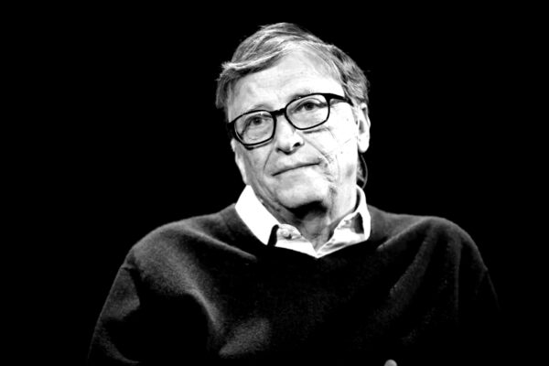](https://thelastamericanvagabond.com/top-news/bill-gates-web-dark-money-influence-part-2-covid-19-operation/)

1 Star2 Stars3 Stars4 Stars5 Stars

###### ***THIS PIECE WILL CONTINUE OUR LOOK INTO BILL GATES AND THE BILL AND MELINDA GATES FOUNDATION.***[***PLEASE SEE PART 1***](https://thelastamericanvagabond.com/top-news/bill-gates-web-dark-money-influence-part-1-philanthropic-narrative-shaping/)***BEFORE READING. IN PART 2,  WE WILL FOCUS ON THE ROLE THE FOUNDATION HAS PLAYED IN THE RESPONSE TO COVID-19, AS WELL AS THE INFLUENCE THE ORGANIZATION HAS ON GLOBAL HEALTH INSTITUTIONS.***

Before we dive into the current COVID-19 crisis, a bit more background on Gates is needed. In the last piece we discussed the history of the Gates Foundation’s investments. What is important to note is that by using the Foundation as the front organization, Gates can donate and influence hospitals, universities, media, governments, and health organizations. The Foundation clearly has the ability to shape the decisions made by some of the institutions they fund, including when these decisions go against the desires of the masses they claim to be helping.

For example, in 2017 [**Independent Science News released a report**](https://www.independentsciencenews.org/news/gates-foundation-hired-pr-firm-to-manipulate-un-over-gene-drives/%20)**detailing how the Bill and Melinda Gates Foundation paid PR firm Emerging Ag $1.6 million to *“recruit a covert coalition of academics to manipulate a UN decision-making process over gene drives.”* Emails released by Freedom of Information Act Request reveal**that the Gates’ recruitment effort was part of a plan to *“fight back against gene drive moratorium proponents.”* **Gene drives are a controversial genetic extinction technology promoted as a way to eliminate mosquitoes with malaria, agricultural pests, and invasive species.**

At the 2016 United Nations Convention on Biological Diversity, 179 international organizations called for a UN moratorium on gene drives. The opponents of this technology also circulated a letter, “[A Call for Conservation with a Conscience: No Place for Gene Drives in Conservation](http://www.synbiowatch.org/wp-content/uploads/2016/09/letter_vs_genedrives.pdf),” signed by 30 environmental leaders who called for a *“halt to all proposals for the use of gene drive technologies, but especially in conservation.”*The Gates Foundation is [heavily invested in gene driving technology](https://www.scientificamerican.com/article/a-revolutionary-genetic-experiment-is-planned-for-a-west-african-village-if-residents-agree/) and was not happy to see a diverse and unified push-back against gene driving. The Foundation hired Emerging Ag — who have their own web of connections to Big Pharma and Big Ag — to shut down the opponents of gene driving. Emerging Ag was successful and the moratorium was [shot down](https://www.scientificamerican.com/article/gene-drive-moratorium-shot-down-at-un-meeting/).

Coincidentally, in 2016, the US National Academy of Sciences released a report on gene driving which was co-funded by the [Defense Advanced Research Projects Agency](https://thelastamericanvagabond.com/business/coronavirus-gives-dangerous-boost-darpas-darkest-agenda/) (DARPA) and the Bill and Melinda Gates Foundation. DARPA is also invested in gene drive research. [As The Guardian noted](https://www.theguardian.com/science/political-science/2016/jun/09/the-national-academies-gene-drive-study-has-ignored-important-and-obvious-issues) after the release of the NAS report:

***“The same US defense research agency (DARPA) who paid for the NAS study have made it known that they are going all-in on gene drive research and development of ‘robust’ synthetic organisms. There is good reason to be worried.”***

Moreover, Jim Thomas of the ETC Group, which monitors the impact of emerging technologies and corporate strategies on biodiversity, agriculture and human rights, told ISN that he believes gene drives are potential biological weapons that could have a “disastrous” impact on human life and food security. *“The fact that gene drive development is now being primarily funded and structured by the US military raises alarming questions about this entire field,”* he stated.

*Independent Science News* also noted:

***“This is also not the first time that the Gates Foundation has used academics to influence public and private opinion on genetic engineering technologies, as witnessed by its funding of the***[***Cornell Alliance for Science***](https://www.independentsciencenews.org/news/gates-foundation-grants-additional-6-4million-to-cornells-controversial-alliance-for-science/)***.”***

The private emails obtained by *Independent Science News* add to the mountains of evidence detailing how Gates is able to pressure organizations to carry out his interests, and that of his foundation.

### THE GLOBAL HEALTH MAFIA

[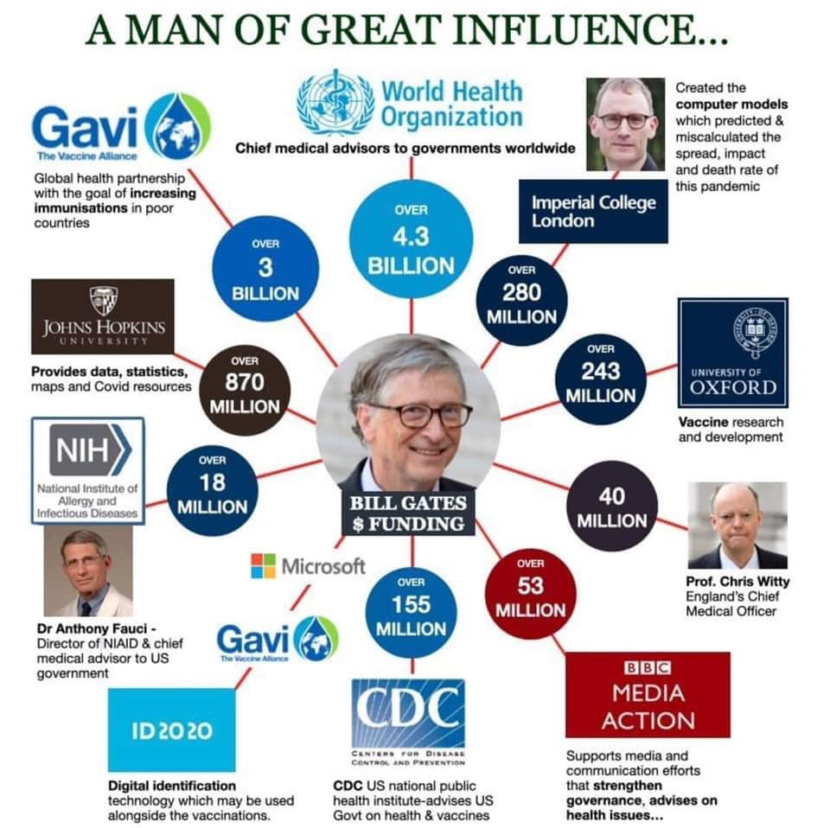](https://secureservercdn.net/50.62.194.30/cm2.2c3.myftpupload.com/wp-content/uploads/2020/05/gates.jpg)

Considering these alarming reports of Gates’ influence on public health policy, it is important to take a moment to examine the current response to COVID-19. When we look at the players and institutions involved, *do we see Gates’ influence and money? If so, what does this mean for public health? Will Gates’ mammoth influence and finances allow him to personally direct the course of the COVID-19 recovery?*

Let’s start by looking at Dr. Anthony S. Fauci, Director of National Institute of Allergy and Infectious Diseases (NIAID), part of the National Institutes of Health, and a leader in the fight against COVID-19. Unfortunately, when it comes to Fauci and NIAID we clearly see the influence of Bill Gates. In 2010, NIAID and the Bill and Melinda Gates Foundation [announced their “Decade of Vaccines Collaboration,”](https://www.gatesfoundation.org/Media-Center/Press-Releases/2010/12/Global-Health-Leaders-Launch-Decade-of-Vaccines-Collaboration%2520%2520%2520%2520%2520%2520%2520%2520%2520%2520%2520%2520%2520%2520%2520%2520%2520%2520%2520%2520%2520%2520%2520-) calling for coordination across the “international vaccine community” and the creation of a “Global Vaccine Action Plan.” Dr. Fauci was appointed to the Leadership Council of the partnership. Similarly, Bill Gates has been [partnering with the NIH](https://www.fic.nih.gov/News/Pages/2013-bill-gates-nih-barmes-global-health-lecture.aspx) for [several](https://www.nih.gov/news-events/news-releases/nih-launches-new-collaboration-develop-gene-based-cures-sickle-cell-disease-hiv-global-scale) [years](https://directorsblog.nih.gov/tag/bill-and-melinda-gates-foundation/).

[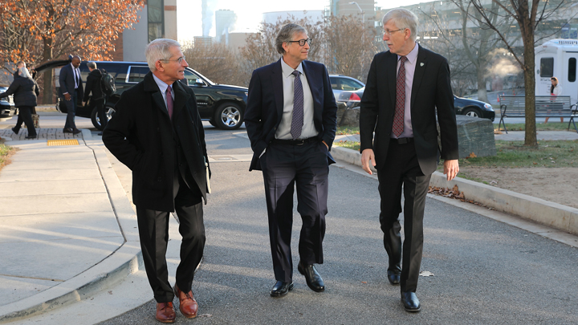](https://secureservercdn.net/50.62.194.30/cm2.2c3.myftpupload.com/wp-content/uploads/2020/05/bill-gates-2018-resized.jpg)

In late April, [the news broke](https://themindunleashed.com/2020/04/us-chinese-governments-collaborated-coronavirus-research.html) that Fauci’s NIAID donated a total of $7.4 million to research involving bat coronaviruses. The investments added fuel to the theory that COVID-19 might be a bioengineered virus which was purposefully or accidentally released from the Wuhan Institute of Virology in Wuhan, China. The news of the funding begs the obvious question; did Gates’ money influence or fund the NIAID’s coronavirus research? Time will tell.

Another important player with connections to Gates is Dr. Deborah Birx, an American physician and diplomat serving as the United States Global AIDS Coordinator for Presidents Barack Obama and Donald Trump since 2014. She is currently the Coronavirus Response Coordinator for the Trump Administration’s White House Task Force. Birx also sits on the [Board of The Global Fund](https://www.theglobalfund.org/en/board/members/), an organization which was promised a [$750 million investment](https://www.gatesfoundation.org/Media-Center/Press-Releases/2012/01/Foundation-Commits-$750-Million-to-Global-Fund) by the Bill and Melinda Gates Foundation in 2012. The Global Fund also features board member Kieran Daly, the Deputy Director of Global Policy and Advocacy for the Gates Foundation.

*“The Bill & Melinda Gates Foundation is a key partner of the Global Fund, providing cash contributions, actively participating on its board and committees, and supporting the Global Fund’s advocacy, communications and fundraising efforts,”* the [Global Fund states](https://www.theglobalfund.org/en/private-ngo-partners/resource-mobilization/bill-melinda-gates-foundation/).

The John Hopkins University has been an equally important member of the global response to COVID-19. The university’s [calculations of global infection and death rates](https://coronavirus.jhu.edu/map.html) are commonly cited in mainstream media. Yet, once again, we find the Bill and Melinda Gates Foundation has been [investing in John Hopkins for two decades](https://www.gatesfoundation.org/Media-Center/Press-Releases/1999/05/Johns-Hopkins-University-School-of-Public-Health).

Finally, it was [recently reported](https://wellcome.ac.uk/press-release/bill-melinda-gates-foundation-wellcome-and-mastercard-launch-initiative-speed) that the organization known as the Wellcome Trust has partnered with the Bill and Melinda Gates Foundation and MasterCard to “catalyze the initial work” of the COVID-19 Therapeutics Accelerator. The Accelerator is supposed to accelerate and evaluate “new and repurposed drugs and biologics to treat patients with COVID-19 in the immediate term.” What was not mentioned is that the Gates Foundation has been a “[Trustee](https://www.gatesfoundation.org/How-We-Work/Quick-Links/Grants-Database/Grants/2016/07/OPP1151904)” of the Wellcome Trust for several years. Interestingly, in 2017, Mark Henderson, Director of Communications for Wellcome Trust participated in a panel called “[Deep Dive: Preventing Pandemics](https://www.aspenideas.org/sessions/deep-dive-preventing-pandemics).” Dr. Anthony Fauci also participated in the panel discussion.

One could chalk up Fauci and Wellcome Trust’s involvement with a panel about pandemics as perfectly reasonable — after all, these are professionals who are focused on global health. However, to ignore that Bill Gates’ fingerprints are all over the global health industry would be a mistake.

Based on The Gates Foundation’s track record of hiring PR firms to shut down detractors or using their money to influence institutions, one could be forgiven for assuming that the foundation would not be high on the list of potential leaders for a public health crisis. Unfortunately, as of May 2020, Bill Gates and his Foundation are still being promoted as heroes in the fight against COVID-19.

### WHO IS RUNNING THE WHO?

Since the outbreak of COVID-19, both Bill Gates and the World Health Organization have stepped onto the center stage as the world looks to them for answers. By now, it is common knowledge that the Bill and Melinda Gates Foundation is the number one non-state donor to the WHO. The United States has been the top state donor but that may change under the Trump administration. Gates was also the first non-state individual to give a keynote address to the WHO general assembly.

According to a [report by *Politico*](https://www.politico.eu/article/bill-gates-who-most-powerful-doctor/), Bill Gates’ opinion (and money) has so much influence on the WHO that officials privately call it “the Bill Chill.” Sixteen officials speaking on the condition of anonymity told Politico that Gates has an out-sized influence on the politics of the WHO and few dare challenge him. *“He is treated liked a head of state, not only at the WHO, but also at the G20,*” a Geneva-based NGO representative stated.

The accusations of Gates’ influence were seconded by Foreign Affairs when they [reported](https://www.foreignaffairs.com/articles/2012-03-06/money-or-die) that *“few policy initiatives or normative standards set by the World Health Organization are announced before they have been casually, unofficially vetted by Gates Foundation staff.”*

The WHO’s current Director General is Tedros Adhanom, a former Health Minister of Ethiopia and a physician. During his tenure as Minister of Health of Ethiopia, Tedros collaborated with the Clinton Foundation and the Bill and Melinda Gates Foundation to [work on vaccines](https://www.gatesfoundation.org/Media-Center/Press-Releases/2012/02/Foundation-Appoints-Ethiopia-Representative), among other health measures. Politico reported that prior to Tedros being selected for the WHO position in 2017 Gates was accused of supporting Tedros and using his influence to help win the nomination.

While most of the member country delegates expressed their belief that Gates is well intentioned, some feared that the Gates Foundation’s money comes from “big business” and could *“serve as a Trojan horse for corporate interests to undermine WHO’s role in setting standards and shaping health policies.”*

The most important takeaway is that the fees paid by WHO member countries account for less than a quarter of the $4.5 billion biennial budget — leaving Gates, governments, and other foundations to fill the gap. These donations are allocated for specific projects and the WHO cannot decide how to use them. In the case of the Bill and Melinda Gates Foundation, those funds typically go towards vaccine programs.

No matter which way you approach the solutions being presented as the answer to the COVID-19 pandemic you will find Bill Gates’ fingerprints. Repeatedly he has used his money and influence to profit and steadily gain power without ever being elected to political office.

*In part 3 of this investigation we will examine the strategies Bill Gates has called for in response to COVID-19. We will also see how Bill Gates and the Rockefeller family have both been predicting a situation like the one we are currently witnessing unfold. Finally, we will show how this crisis presents the perfect opportunity for Gates and his cohorts to reap massive profits and position themselves at the head of an emerging Technocratic State.*

HEALTH SURVEILLANCE, EVENT 201 AND THE ROCKEFELLER CONNECTION

[12 COMMENTS](https://thelastamericanvagabond.com/top-news/bill-gates-web-dark-money-influence-part-3-health-surveillance-event-201-rockefeller-connection/)

https://secureservercdn.net/50.62.194.30/cm2.2c3.myftpupload.com/wp-content/themes/hades/images/clock.png 29 MAY 2020  https://secureservercdn.net/50.62.194.30/cm2.2c3.myftpupload.com/wp-content/themes/hades/images/author.png POSTED BY DERRICK BROZE

[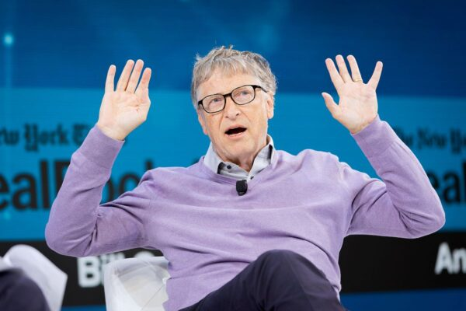](https://thelastamericanvagabond.com/top-news/bill-gates-web-dark-money-influence-part-3-health-surveillance-event-201-rockefeller-connection/)

1 Star2 Stars3 Stars4 Stars5 Stars

LOCKDOWNS, CONTACT TRACING, DIGITAL CERTIFICATES, AND VACCINES

Over the last four months Bill Gates has made dozens of media appearances where he has called for several controversial “solutions” to  COVID-19. Gates says these proposals must be implemented before society can go back to “normal.” From calling for [extended lock downs](https://www.independent.co.uk/news/world/americas/coronavirus-lockdown-how-long-when-end-bill-gates-shut-down-a9446966.html), health surveillance (aka [contact tracing](https://thehill.com/changing-america/well-being/prevention-cures/494789-gates-more-testing-and-contact-tracing-needed-to)) and [digital certificates](https://www.reddit.com/r/Coronavirus/comments/fksnbf/im_bill_gates_cochair_of_the_bill_melinda_gates/).

The science behind the lock downs has been called into question numerous times by health experts. Most recently, Michael Levitt, a Stanford University professor who predicted the initial trajectory of the pandemic, [stated](https://www.telegraph.co.uk/news/2020/05/23/lockdown-saved-no-lives-may-have-cost-nobel-prize-winner-believes/) that he believed the lockdown was a “[huge mistake](https://www.youtube.com/watch?v=bl-sZdfLcEk)” and may have actually cost lives. TLAV has also [exposed contract tracing](https://thelastamericanvagabond.com/top-news/we-need-army-contact-tracers-meet-enforcement-arm-new-normal/) and the call for an “army” of people to monitor the public as an expansion of surveillance. Coincidentally, it was reported just this week that the Gates Foundation recently [invested hundreds of millions of dollars into tech companies like Google](https://markets.businessinsider.com/news/stocks/gates-foundation-bought-apple-amazon-google-stock-first-quarter-2020-5-1029234223), who may end up building the contact tracing infrastructure.

What Gates describes as “digital certificates” sounds identical to what some are calling “immunity passports,” a form of digital identification that will hold an individual’s health data, as well as their vaccine status. During a Reddit AMA, [Gates stated](https://www.reddit.com/r/Coronavirus/comments/fksnbf/im_bill_gates_cochair_of_the_bill_melinda_gates/), *“Eventually we will have some digital certificates to show who has recovered or been tested recently or when we have a vaccine who has received it.”*What Gates describes – a digital certificate to prove who has been vaccinated – sounds similar to the recent calls for passengers to use [immunity passports before being allowed to fly](https://thelastamericanvagabond.com/top-news/your-immunity-passport-future-begins-to-materialize-as-airlines-call-for-digital-id-tracking-systems/).

However, Gates’ statements and philanthropy reveal his primary focus in the “fight for global health:” the promotion of vaccinations for the entire world. Rather than focus on clean water, access to housing, or any number of other proposals to help the world’s poorest, Gates believes that access to vaccines is most pressing. Long before COVID-19 the Gates Foundation has been involved in funding controversial vaccine efforts in Africa and India.

A 2015 report titled, [*Philanthropic Power and Development: Who shapes the agenda?*](https://www.globalpolicy.org/images/pdfs/GPFEurope/Philanthropic_Power_online.pdf), examines the influence of global philanthropy and provides examples of the undue influence Gates and others can wield. The report outlines much of what we describe in [Part 1](https://thelastamericanvagabond.com/top-news/bill-gates-web-dark-money-influence-part-1-philanthropic-narrative-shaping/) of this investigation, including how, “*through the placement of Foundation staff in decision-making bodies of international organizations and global health partnerships”*the Gates Foundation influences and guides public health policy. The Gates Foundation is a board member not only of GAVI, but also of the Global Fund, the Partnership for Maternal, Newborn and Child Health, the Medicines for Malaria Venture, the Roll Back Malaria Partnership, the TB Alliance, the Stop TB Partnership, and many others.

The investigation also provides detail on Gates’ investments in vaccines and his connections with vaccine manufacturers. As reported in [Part 2](https://thelastamericanvagabond.com/top-news/bill-gates-web-dark-money-influence-part-2-covid-19-operation/) of this investigation, in 2010 the Bill and Melinda Gates Foundation launched the “Decade of Vaccines” and called for a “Global Vaccine Action Plan.” They also helped created the public-private partnership known as GAVI, or the Global Alliance for Vaccines and Immunization.

*“The Gates Foundation provided an initial five-year pledge of US$750 million as seed money to launch this global public-private partnership in 2000 and has remained its driving force and its largest donor,”* the report states. *“Between 2000 and 2014 the Gates Foundation contributed 23 percent (US$2,287.94 million) of the total donor funding of around US$9.9 billion.”*

The report noted that researchers have been critical of GAVI for following a “Gates-approach” on global health challenges, *“focusing on disease-specific vertical health interventions (through vaccines), instead of horizontal and holistic approaches (e.g., health system strengthening).”*Additionally, there is evidence that the Gates Foundation’s support of GAVI has encouraged vaccine manufacturers to produce specific vaccines resulting in *“over $1 billion to Pfizer and GlaxoSmithKline (GSK).”*

The non-governmental organization Doctors without Borders (MSF) has also questioned the GAVI Alliance’s overall impact on vaccine affordability, stating that *“the cost to fully immunize a child was 68 times more expensive in 2014 than it was in 2001.”*MSF also calls for GAVI to exclude pharmaceutical companies from their board of directors in order to reduce conflicts of interest.

One of the most important takeaways from the investigation is that the Gates Foundation operates a revolving door between Foundation staff and Big Pharma companies like Merck and GSK. The report provides several examples of this revolving door, including Trevor Mundel, the president of the Global Health Division of the Gates Foundation, previously worked with Novartis, Pfizer and Parke-Davis. Mundel’s predecessor, Tachi Yamada, had been an executive and board member of GSK. Kim Bush, responsible for partnership initiatives with healthcare for the Gates Foundation,  formerly worked for Baxter International Healthcare Corporation. Penny Heaton, Director of Vaccine Development at the Gates Foundation since 2013, worked before for Novartis Vaccines and Diagnostics and for Merck & Co.

THE GATES FOUNDATION AND MRNA VACCINES

[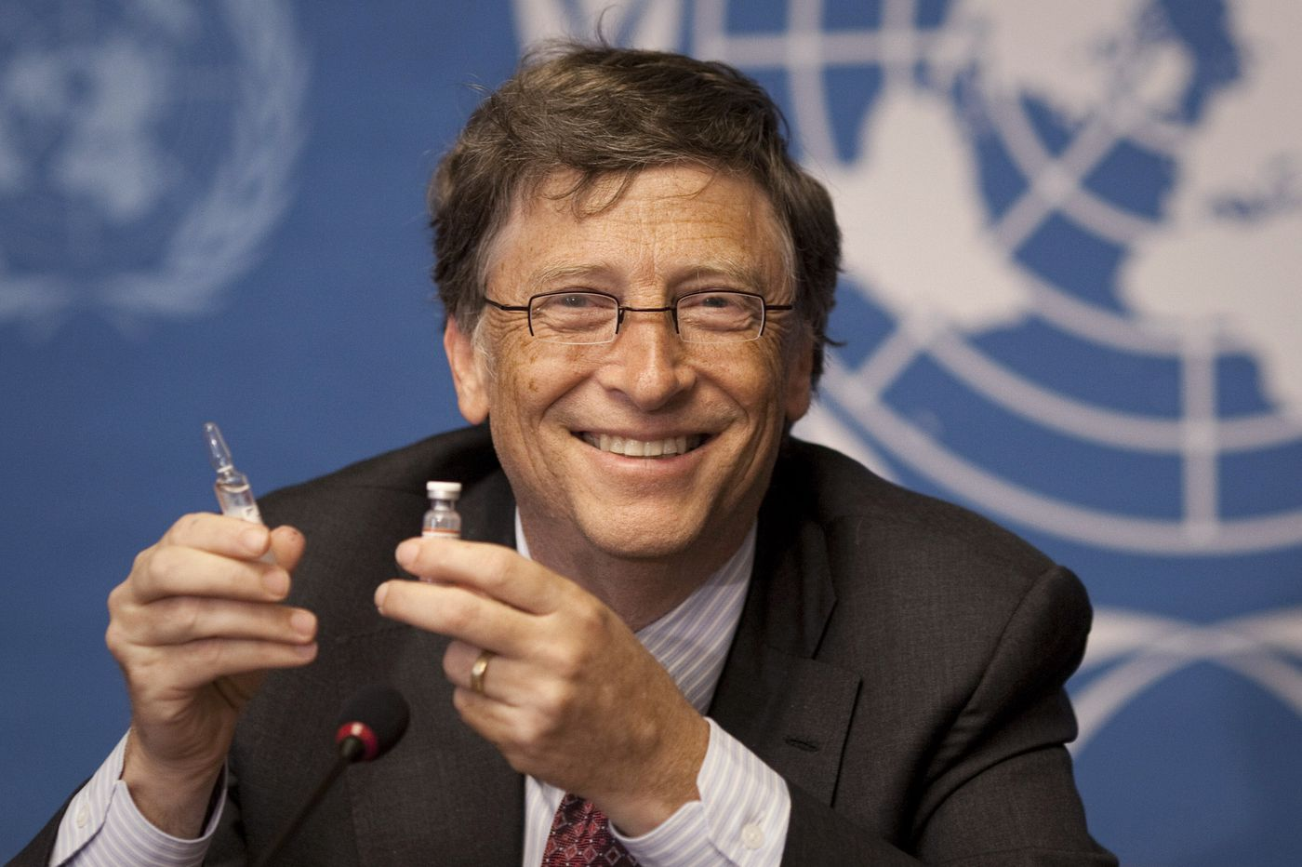](https://secureservercdn.net/50.62.194.30/cm2.2c3.myftpupload.com/wp-content/uploads/2020/05/3QIB3YQ4F5BSVCZUWE5Y3RFOD4.jpg)

Another interesting note from the report is how the Foundation has a $52 million equity stage in German pharmaceutical company, CureVac. The collaboration is meant to speed up the development of messenger RNA (mRNA) vaccines against various diseases, including rotavirus, HIV and respiratory syncytial virus.

The mRNA-vaccine has been discussed as a potential candidate for the COVID-19 vaccine. Specifically, biotech company Moderna Therapeutics is leading the way for mRNA therapeutics and potential vaccines. Moderna’s RNA vaccine program [has received $100 million](https://www.modernatx.com/about-us/modernas-key-milestones-and-advancements) in funding from the Gates Foundation. Moderna’s controversial mRNA vaccine was also developed with a [$25 million grant](https://investors.modernatx.com/news-releases/news-release-details/darpa-awards-moderna-therapeutics-grant-25-million-develop) from the Defense Advanced Research Project Agency (DARPA).

As [TLAV reported](https://thelastamericanvagabond.com/top-news/trump-appoints-big-pharma-exec-connected-bill-gates-head-vaccine-developments/), Donald Trump also appointed Dr. Moncef Slaoui – a former Big Pharma exec who up until recently sat on the board of Moderna – as his “Vaccine Czar” to lead “Operation Warp Speed,” the Trump administration’s effort to fast track a vaccine by the end of 2020. In 2016, Slaoui was [appointed to the Board of Directors of Moderna Therapeutics](https://investors.modernatx.com/news-releases/news-release-details/moncef-m-slaoui-phd-joins-modernas-board-directors). He resigned upon being appointed to a position in the current US administration.

TLAV writer Whitney Webb [recently reported](https://thelastamericanvagabond.com/top-news/bats-gene-editing-bioweapons-recent-darpa-experiments-raise-concerns-amid-coronavirus-outbreak/) on Moderna’s role in the fight against COVID-19 and their connections to the Gates Foundation:

*“The Coalition for Epidemic Preparedness Innovations (CEPI) announced that it would fund three separate programs in order to promote the development of a vaccine for the new coronavirus responsible for the current outbreak.*

*CEPI — which describes itself as “a partnership of public, private, philanthropic and civil organizations that will finance and co-ordinate the development of vaccines against high priority public health threats” —****was founded in 2017 by the governments of Norway and India along with the World Economic Forum and the Bill and Melinda Gates Foundation.****Its massive funding and close connections to public, private and non-profit organizations have positioned it to be able to finance the rapid creation of vaccines and widely distribute them.*

*CEPI’s recent announcement revealed that it would fund two pharmaceutical companies — Inovio Pharmaceuticals and Moderna Inc. — as well as Australia’s University of Queensland, which became*[*a partner*](https://cepi.net/news_cepi/cepi-partners-with-university-of-queensland-to-create-rapid-response-vaccines/)*of CEPI early last year. Notably, the two pharmaceutical companies chosen have close ties to and/or strategic partnerships with DARPA and are developing vaccines that controversially involve genetic material and/or gene editing. The University of Queensland also has ties to DARPA, but those ties are not related to the university’s biotechnology research, but instead*[*engineering*](https://www.eurekalert.org/pub_releases/2011-02/uoc--uea021411.php)*and*[*missile development*](https://www.thedrive.com/the-war-zone/12456/the-united-states-and-australia-quietly-test-hypersonic-missiles?iid=sr-link3)*.”*

Webb goes on to detail how Moderna is working with the U.S. NIH to develop a vaccine for the new coronavirus and how the project will be entirely funded by CEPI, which in turn was founded and funded by the Bill and Melinda Gates Foundation.

It should come as no surprise that Bill Gates is now openly [supporting RNA vaccines](https://www.gatesnotes.com/Health/What-you-need-to-know-about-the-COVID-19-vaccine). The development of these vaccines — and the overall effort of Operation Warp Speed — is ignoring the already shaky protocols and safety measures for manufacturing vaccines. Operation Warp Speed and the subsequent human trials involving 100,000 volunteers *“will compress what is typically*[*10 years of vaccine development*](https://www.reuters.com/article/us-health-coronavirus-usa-vaccine-exclus-idUSKBN22Y2L3)*and testing into a matter of months.”*

The rush to get the public a vaccine which has not been properly tested is even more worrisome considering Gates’ recent statements about the need to vaccinate the entire world’s population. In a [blog on his website](https://www.gatesnotes.com/Health/Pandemic-Innovation), Gate states, *“The goal is to pick the one or two best vaccine constructs and vaccinate the entire world—that’s 7 billion doses if it is a single-dose vaccine, and 14 billion if it is a two-dose vaccine.”*

Gates’ push for a mandatory vaccine will likely heavily impact the decisions of the WHO, the CDC, and other global health organizations which he funds, influences, or is a board member of. Gates’ funding of a “[quantum-dot tattoo](http://news.rice.edu/2019/12/18/quantum-dot-tattoos-hold-vaccination-record/)” that can store vaccination records has done little to quell dissent and fear of his true motivations.

Despite the heralding of Gates as a hero who has saved millions of lives, the thought of forcing vaccinations has sparked a growing opposition to vaccines and concerns about their safety. Whether it’s the [CDC whistleblower](https://truthinmedia.com/has-the-cdc-whistleblower-been-given-immunity-to-speak-about-vaccines/), [Dr. Andrew Zimmerman’s testimony](http://fullmeasure.news/news/cover-story/the-vaccination-debate) about the safety of vaccines, or simply the support of freedom of choice – people around the world are skeptical of the safety of the vaccines and the influence of Big Pharma and are not likely to accept a mandated vaccine quietly.

THE ROCKEFELLER CONNECTION, LOCK STEP, AND EVENT 201

[](https://secureservercdn.net/50.62.194.30/cm2.2c3.myftpupload.com/wp-content/uploads/2020/05/prisonplanet.jpg)

As we wrap up our investigation into Bill Gates and consider his ulterior motives, it’s important to take stock of the company that he keeps and the philosophies which he has promoted.

The report,*Philanthropic Power and Development: Who shapes the agenda?*, also provides an important background on the origins of modern philanthropy and the ability of that money to influence global health, food, and agriculture policy. The researchers outline the role of the Rockefeller and Carnegie dynasties in the creation of American philanthropy:

*“The roots of modern philanthropy can be traced back to the beginning of the 20th century in the United States when business tycoons John D. Rockefeller and Andrew Carnegie set up the first large American foundations,****primarily as a way to shield some of their income from taxation but also as a way to garner prestige and influence in the US and world affairs.***

*In 1911 Andrew Carnegie established the Carnegie Corporation of New York and gave it an endowment of US$125 million, making it the largest single philanthropic trust ever established up to that time. A year before, Carnegie, who made his fortune in the steel industry, founded the Carnegie Endowment for International Peace, which became one of the leading foreign policy think tanks in the USA.”*

Ironically, the formation of the Rockefeller Foundation sounds eerily similar to Gates’ own story of facing antitrust and monopoly accusations during his time at Microsoft and then going on to found the Bill and Melinda Gates Foundation as a way to rewrite history and create a hero persona around himself.

*“The Rockefeller Foundation was established in 1913, two years after the US Supreme Court ruled that John D. Rockefeller’s Standard Oil Company, was an illegal monopoly and ordered it to be broken up into smaller companies. The dissolution of the then world’s largest oil company made its founder and major shareholder John D. Rockefeller the richest man in the world.****With the establishment of his foundation, he could insulate a large part of his fortune from income and inheritance taxes.****“*

Philanthropy and tax evasion are not the only commonalities between Bill Gates and the Rockefellers. According to genealogy records, Gates is [related to the Rockefeller family via Nelson Rockefeller](https://famouskin.com/famous-kin-chart.php?name=34818+bill+gates&kin=14634+nelson+rockefeller&via=68483+stephen+gifford), a former Vice President of the U.S. However, the connections go beyond being associated by distant relatives. Both the Rockefeller Foundation and he Gates Foundation seemingly “predicted” a scenario much like the pandemic unfolding in front of our eyes.

On October 18, 2019, the Bill and Melinda Gates Foundation partnered with the John Hopkins Center for Health Security and the World Economic Forum on a high-level pandemic exercise known as Event 201. Gates is a long time “[Agenda Contributor](https://www.weforum.org/agenda/authors/billgates/)” for the WEF and has donated to John Hopkins. Event 201 simulated how the world would respond to a coronavirus pandemic which swept around the planet. The simulation imagined 65 million people dying, mass lock downs, quarantines, censorship of alternative viewpoints under the guise of fighting “disinformation,” and even floated the idea of arresting people who question the pandemic narrative.

Coincidentally, one of the players involved with Event 201 was Dr. Michael Ryan, the head of the [World Health Organization’s team](http://origin.who.int/about/who_reform/emergency-capacities/oversight-committee/michael-ryan/en/) responsible for the international containment and treatment of COVID-19. Ryan called for looking into families to find potentially sick individuals and isolate them from their families.

The Rockefeller Foundation imagined a similar scenario in 2010 as part of their document, “[Scenarios for the Future of Technology and International Development](https://www.nommeraadio.ee/meedia/pdf/RRS/Rockefeller%2520Foundation.pdf).” This document includes a scenario called “Lockstep”, which describes a pandemic sweeping the world and resulting in more authoritarian control from governments in developed countries. The document also describes the response to the pandemic as follows:

*“During the pandemic, national leaders around the world flexed their authority and imposed airtight rules and restrictions, from the****mandatory wearing of face masks to body-temperature checks at the entries to communal spaces like train stations and supermarkets****. Even after the pandemic faded, this more authoritarian control and oversight of citizens and their activities stuck and even intensified.”*

In the imagined scenario the Rockefeller foundation predicts that *“scanners using advanced functional magnetic resonance imaging (fMRI) technology become the norm at airports and other public areas to detect abnormal behavior that may indicate “antisocial intent.”* Interestingly, the Transportation Security Administration recently [announced plans to check temperatures at American airports](https://edition.cnn.com/2020/05/15/politics/tsa-coronavirus-temperature-check-airports/index.html). The document goes on to describe how, eventually, the people of the world tire of the control and civil unrest would begin:

***“By 2025, people seemed to be growing weary of so much top-down control and letting leaders and authorities make choices for them. Wherever national interests clashed with individual interests, there was conflict. Sporadic pushback became increasingly organized and coordinated, as disaffected youth and people who had seen their status and opportunities slip away—largely in developing countries—incited civil unrest.”***

While it might be convenient to dismiss Event 201 and Lock Step as a coincidence, it would be short-sighted to ignore them considering the Gates and Rockefeller Foundations are heavily involved in funding the global health industry. While theories abound over whether the COVID-19 pandemic was planned or engineered in someway, as if to mimic the plans discussed in Event 201 and Lock Step, hard evidence if currently lacking. Still, we should not dismiss them completely.

REDUCING THE POPULATION VIA EUGENICS

The Gates and Rockefeller dynasties are also united by their common interest in eugenics, the debunked science which promoted the idea that people of “good birth” should be encouraged to reproduce while those with “bad genes” should be discouraged from breeding or sterilized altogether. The [science](https://plato.stanford.edu/entries/eugenics/) was developed by Francis Galton as a strategy for improving the human race. The idea was extremely popular in America before the Nazis embraced the doctrine and took it to the extreme.

Eugenics was also extremely popular with the Rockefeller family. A report from the [Hudson Institute notes](https://www.hudson.org/research/9747-philanthropy-s-original-sin), *“the first American foundations were deeply immersed in eugenics the effort to promote the reproduction of the fit and to suppress the reproduction of the unfit.”*The report states that the Rockefellers and other early American philanthropists believed in “philanthropic eugenics,” the idea that they could use their money to create foundations which would promote the philosophy of eugenics.

The Rockefeller Foundation and family helped fund researchers at the Kaiser Wilhelm Institutes in Germany who were involved in the Nazi sterilization programs, funded the Eugenics Records Office, and many other programs promoting population control. In 1952, after the Nazis eugenics experiments were widely known, John D. Rockefeller III helped created the Population Council to promote eugenics without the baggage of the term.

In his book, *Showing Up for Life*, Bill Gates’ father, William H. Gates II, wrote about his admiration for the Rockefeller’s and their philanthropy:

***“A lesson we learned from studying and working with the Rockefellers is that to succeed in pursuing audacious goals you need like-minded partners with whom to collaborate.***

***And we learned that such goals are not prizes claimed by the short-winded. The Rockefellers stay with tough problems for generations.”***

It appears that Gates II was a supporter of the Rockefellers eugenics philosophy as he served as the head of Planned Parenthood for a time. Planned Parenthood was funded in part by a [$1.5 million donation](https://www.nytimes.com/1979/07/10/archives/gifts-of-john-d-rockefeller-3d-totaled-94-million-over-his-lifetime.html) from the Rockefeller-created Population Council. Gates II was preceded at Planned Parenthood by Alan Guttmacher, who simultaneously served as the [Director of the American Eugenics Society](https://archive.org/details/AMERICANEUGENICSSOCIETYMEMBERS/page/n449/mode/2up).

This interest in eugenics may have gone back three generations to Bill Gates’ grandfather, William H. Gates, as the American Eugenics Society did [have a member](https://archive.org/details/AMERICANEUGENICSSOCIETYMEMBERS/page/n157/mode/2up) by the name of “William H. Gates” in the 1920s. The William H. Gates listed on the AES roster was listed as “professor” and there is a [professor William H. Gates from Louisiana State University](https://louisianadigitallibrary.org/islandora/object/lsu-ua-uap%253A1214) but there is not yet evidence that [Gates’ grandfather](https://www.geni.com/people/William-Gates-Sr/6000000006276546157) is the same William H. Gates.

Regardless, the present day Gates family has a habit of spending time around their fellow philanthropic eugenicists. In December 2001, William H. Gates received the inaugural “[Andrew Carnegie Medals of Philanthropy](https://www.carnegie.org/news/articles/first-andrew-carnegie-medals-awarded-to-seven-visionaries-of-modern-philanthropy/)” for his charity work. Gates Sr. received his award alongside Walter H. and Leonore Annenberg on behalf of the Annenberg Foundation, Brooke Astor, Irene Diamond, David and Laurance S. Rockefeller on behalf of the Rockefeller family, George Soros and Ted Turner. Although Bill Gates is not pictured, the Carnegie Corporation mentions that the senior Gates was representing the “Gates family.”

[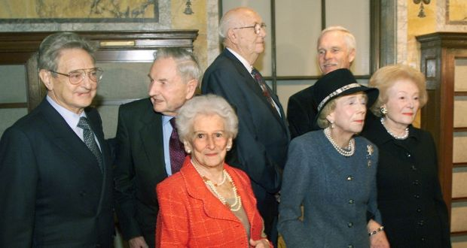](https://secureservercdn.net/50.62.194.30/cm2.2c3.myftpupload.com/wp-content/uploads/2020/05/image-1.jpg)

[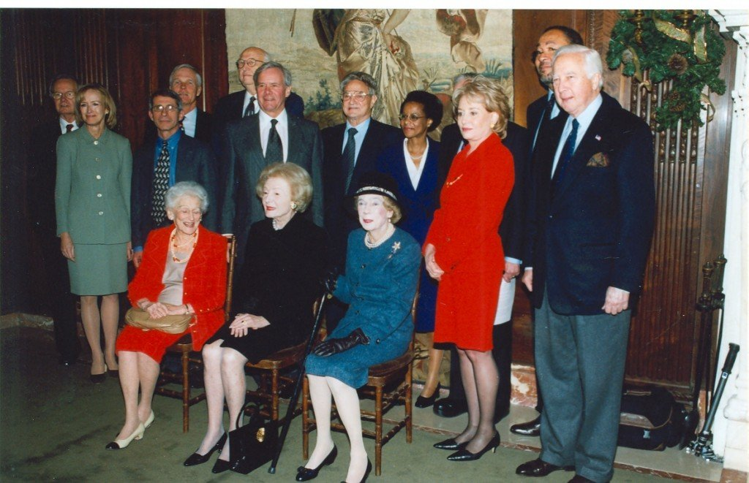](https://secureservercdn.net/50.62.194.30/cm2.2c3.myftpupload.com/wp-content/uploads/2020/05/EU9N3pdX0AIyiYt.jpeg)

More recently, in 2010 Bill Gates was seen with fellow billionaires in an event which was described by the corporate media as *“They’re called the Good Club – and they want to save the world.”* [The Guardian reported](http://theguardian.com/world/2009/may/31/new-york-billionaire-philanthropists):

*“This is the Good Club, the name given to the tiny global elite of billionaire philanthropists who recently held their first and highly secretive meeting in the heart of New York City.*

*The names of some of the members are familiar figures:****Bill Gates, George Soros, Warren Buffett, Oprah Winfrey, Michael Bloomberg, David Rockefeller and Ted Turner****. But there are others, too, like business giants Eli and Edythe Broad, who are equally wealthy but less well known. All told, its members are worth $125bn.”*

The Guardian also notes that Rockefeller, Gates, and Buffet organized the meeting. [The Wall Street Journal reported](https://blogs.wsj.com/wealth/2009/05/26/billionaires-try-to-shrink-worlds-population-report-says/) that the meeting was focused on slowing population growth, a euphemism for eugenics. The appearance of Ted Turner at both the 2001 meeting and the 2010 meeting should not be a surprise as he has also been a [vocal proponent of population control](https://www.businessinsider.com/ted-turner-urges-world-leaders-to-adopt-chinas-one-child-policy-on-global-scale-2010-12?r=MX&IR=T).

It should also be noted that despite the denials from Bill Gates, he was also an associate of sexual predator Jeffrey Epstein. TLAV writer [Whitney Webb previously documented the relationship](https://www.mintpressnews.com/scrubbed-reports-reveal-new-secrets-of-the-prince-andrew-jeffrey-epstein-relationship/262330/) and the attempts to conceal it. Coincidentally, Epstein was also exposed as a [proponent of eugenics](https://www.theguardian.com/us-news/2019/aug/18/private-jets-parties-and-eugenics-jeffrey-epsteins-bizarre-world-of-scientists).

WILL THE REAL BILL GATES STAND UP?

Now that we have arrived to the end of this investigation into the lives, finances, and history of Bill Gates, we must stop to reflect on his motivations. Is Bill Gates the lovable billionaire philanthropist who could save the world from COVID-19? Is he the financier of dangerous vaccine trials? Is he motivated by a desire to help humanity or is he motivated by a debunked philosophy or race science and eugenics?  
If we are to judge an individual by the company they keep, by the projects they finance, and by [the words they say](https://www.youtube.com/watch?v=obRG-2jurz0), then it should be clear that the Gates family has a history of promoting and supporting eugenics. Armed with this knowledge we can take a fresh look at Bill Gates’ philanthropy and come to understand that he might have motives which are very different from his public statements.

The fact is that Bill Gates runs in elite circles where the promotion of eugenics, population control, sterilization, and other social engineering tactics are the norm. This man is being propped up in front of the world as the hero we desperately need to free us from the grips of the COVID-19 pandemic. If his PR stunts and philanthropy succeed in convincing the people that he is the savior they have been searching for, we are likely to face a future of contact tracing surveillance, digital certificates to travel, forced vaccinations, tracking and restrictions of all movement, and forced quarantines.

The only thing that stands between Gates and his agenda are the free hearts and minds of the world. Our time is short. We must get organized, share this vital information, and [#ExposeBillGates](https://twitter.com/DBrozeLiveFree/status/1266491501556772864).