**Bill Gates is spending billions to ‘save months’ on a coronavirus vaccine**



[**Aarthi Swaminathan**](https://www.yahoo.com/author/aarthi-swaminathan)

**Reporter**

[**Yahoo Finance**](http://finance.yahoo.com/)April 6, 2020

0:05

4:06

Bill Gates: Social distancing comes at 'huge economic price'

Microsoft ([MSFT](https://finance.yahoo.com/quote/MSFT/)) founder and philanthropic billionaire Bill Gates is spending billions of dollars on seven possible vaccines for the coronavirus and the disease it causes, COVID-19, in hopes of finding an end to the pandemic.

Through his philanthropic organization, the Bill & Melinda Gates Foundation, Gates revealed that he was funding several efforts in partnership with other companies and countries to “save months, because every month counts.”

“Our early money can accelerate things,” Gates told [The Daily Show with Trevor Noah](https://www.youtube.com/watch?v=iyFT8qXcOrM). “Of all the vaccine constructs, the seven most promising of those, even though we’ll end up picking at most two of them, we’re going to fund factories for all seven, and just so that we don’t waste time in serially saying, ‘Okay, which vaccine works?’ And then building the factory.”

Gates added that spending a few billion dollars during “the situation we’re in, where there’s trillions of dollars — that’s a thousand times more — trillions of dollars being lost economically, it is worth it.”

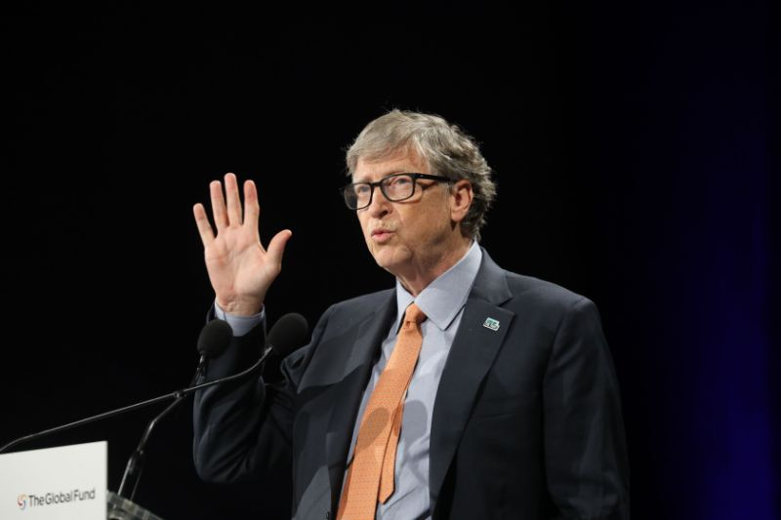

**View photos**

Microsoft founder, Co-Chairman of the Bill & Melinda Gates Foundation, Bill Gates delivers a speech during the conference of Global Fund to Fight HIV, Tuberculosis and Malaria in 2019, in Lyon, France. (Photo: LUDOVIC MARIN/AFP via Getty Images)

More

**‘The ultimate solution... is to create a vaccine’**

There are more than 330,000 cases of the coronavirus infection in the U.S., surpassing the rest of the world, according to [data compiled by Johns Hopkins](https://www.arcgis.com/apps/opsdashboard/index.html#/bda7594740fd40299423467b48e9ecf6) as of Monday morning.

“This is a nightmare scenario, because human-to-human transmission of respiratory viruses can grow exponentially,” Gates told [Fox News](https://www.youtube.com/watch?v=jXHikITwlng) on Sunday. “And we had kept on going to work, traveling like we were.”

Gates noted that with the introduction of [extreme social distancing](https://finance.yahoo.com/news/bill-gates-on-coronavirus-161803530.html?bcmt=1) and [improved testing](https://finance.yahoo.com/news/bill-gates-on-coronavirus-testing-145921900.html), both of which he called for previously, the situation could improve so that the overall death toll falls short of the 100,000-240,000 estimated by the White House.

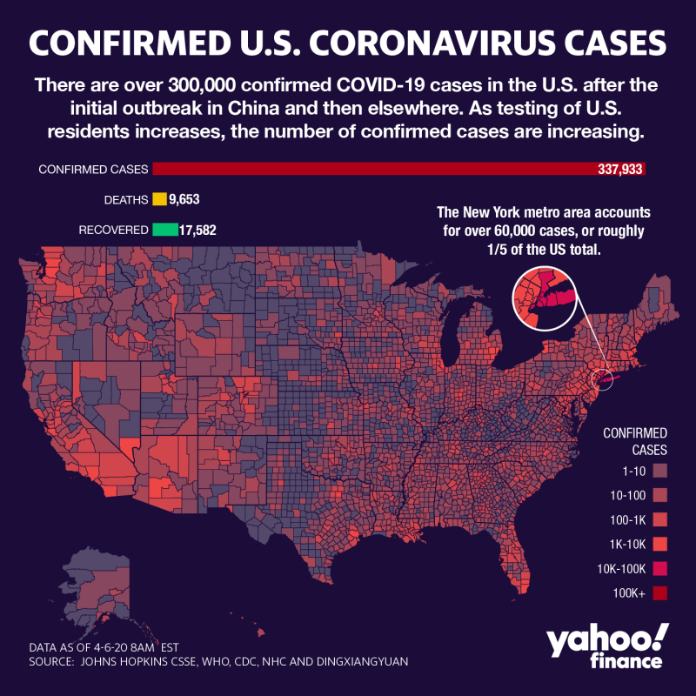

**View photos**

Coronavirus cases are still on the rise. (Graphic: David Foster/Yahoo Finance)

More

“If we do the social distancing properly, we should be able to get out of this with the death number well short of that,” Gates said. “I do think we get the testing fixed, we get all 50 states involved, we’ll be below that. Of course we’ll pay a huge economic price in order to achieve that.”

And spending billions of dollars to find a vaccine is going to be worth it, Gates stressed.

“The ultimate solution, the only thing that really lets us go back completely to normal and feel good about sitting in a stadium with lots of other people, is to create a vaccine,” Gates said. “And not just take care of country, but take that vaccine out to the global population so that we have vast immunity and this thing, no matter what, isn’t going to spread in large numbers.”

**The search for the COVID-19 vaccine**

The Coalition for Epidemic Preparedness Innovations (CEPI) — a global public-private [partnership](https://www.gatesfoundation.org/TheOptimist/Articles/coronavirus-mark-suzman-therapeutics) launched in 2017 that the Gates Foundation funds— has [made investments](https://cepi.net/research_dev/our-portfolio/) in eight vaccine programs, including:

**Moderna**: [CEPI is funding the company’s efforts](https://investors.modernatx.com/news-releases/news-release-details/moderna-announces-funding-award-cepi-accelerate-development) to “develop an mRNA vaccine against the novel coronavirus.” (The company [has already started clinical trials](https://www.businessinsider.com/coronavirus-vaccine-first-dose-administered-in-clinical-trial-2020-3)).

**CureVac**: [CEPI is funding the company’s efforts](https://www.curevac.com/news/curevac-and-cepi-extend-their-cooperation-to-develop-a-vaccine-against-coronavirus-ncov-2019) to “develop a rapid-response vaccine platform” and “accelerated vaccine development, manufacturing and clinical tests.”