**Bill Gates says he's shocked by 'crazy and evil' conspiracy theories linking him to COVID-19 including claims he wanted to use vaccines to microchip billions**

* **Bill Gates said he's shocked by the volume of 'evil' conspiracy theories involving him that have come to light since the beginning of the pandemic**
* **Gates, who has donated $1.7 billion to coronavirus research, has been accused of developing COVID in a lab and plotting to use vaccines to microchip billions**
* **Calling the theories 'evil', Gates said he 'hopes it goes away'**
* **In the first few months of the pandemic, between February and April, conspiracy theories and misinformation linked Gates to the origins of COVID**
* **Then, in May 2020, a  poll found that 28% of US adults believed that Gates was plotting to use a potential vaccine to implant microchips**
* **The Microsoft co-founder said 'we're going to have to get educated about this over the next year' and determine what's driving the conspiracies**

By [LUKE KENTON FOR DAILYMAIL.COM](https://www.dailymail.co.uk/home/search.html?s=&authornamef=Luke+Kenton+For+Dailymail.com)

**PUBLISHED:** 14:46 GMT, 27 January 2021 | **UPDATED:** 20:28 GMT, 27 January 2021

* [e-mail](mailto:?subject=Read%20this:%20Bill%20Gates%20says%20he%27s%20shocked%20by%20%27crazy%20and%20evil%27%20conspiracy%20theories%20linking%20him%20to%20COVID-19%20including%20claims%20he%20wanted%20to%20use%20vaccines%20to%20microchip%20billions&body=Bill%20Gates%20says%20he%27s%20shocked%20by%20%27crazy%20and%20evil%27%20conspiracy%20theories%20linking%20him%20to%20COVID-19%20including%20claims%20he%20wanted%20to%20use%20vaccines%20to%20microchip%20billions%0A%0AMicrosoft%20co-founder%20and%20philanthropist%20Bill%20Gates%20said%20he%20has%20been%20the%20subject%20to%20millions%20of%20posts%20and%20%27crazy%20conspiracy%20theories%27%2C%20insisting%20he%20would%20like%20to%20get%20to%20the%20bottom%20of%20it%20all.%0A%0Ahttps%3A%2F%2Fwww.dailymail.co.uk%2Fnews%2Farticle-9192815%2FBill-Gates-says-hes-shocked-crazy-evil-conspiracy-theories-linking-COVID-19.html%3Fito%3Demail_share_article-top%0A%0A%0AMost%20Read%20Articles%3A%0A%0AHow%20many%20more%20cases%20are%20there%3F%20Hancock%20calls%20for%20%27extra%20special%20precautions%27%20as%20door-to-door%20testing%20of%2080%2C000%20people%20starts%20in%20eight%20postcodes%20after%20ELEVEN%20people%20test%20positive%20for%20dangerous%20South%20African%20variant%20despite%20not%20leaving%20country%0Ahttps%3A%2F%2Fwww.dailymail.co.uk%2Fnews%2Farticle-9210159%2FDoor-door-testing-South-African-variant-start-Surrey.html%3Fito%3Demail_share_article-top_most-read-articles%0A%0AMeghan%20Markle%20says%20taking%20her%20Christian%20names%20off%20son%20Archie%27s%20birth%20certificate%20was%20%27dictated%27%20by%20Buckingham%20Palace%20and%20it%27s%20%27offensive%27%20to%20suggest%20she%20wanted%20to%20be%20%27nameless%27%C2%A0%0Ahttps%3A%2F%2Fwww.dailymail.co.uk%2Fnews%2Farticle-9208453%2FMeghan-Markle-says-taking-names-Archies-birth-certificate-dictated-Buckingham-Palace.html%3Fito%3Demail_share_article-top_most-read-articles%0A%0A%27Disgusted%27%20Topshop%20staff%20were%20officially%20told%20they%27d%20lost%20their%20jobs%20TWO%20HOURS%20after%20Asos%20announced%20%C2%A3330m%20takeover%20on%20Twitter%20-%20as%20S)

**8.5k**shares

**[2.8k](https://www.dailymail.co.uk/news/article-9192815/Bill-Gates-says-hes-shocked-crazy-evil-conspiracy-theories-linking-COVID-19.html" \l "comments)**

[View comments](https://www.dailymail.co.uk/news/article-9192815/Bill-Gates-says-hes-shocked-crazy-evil-conspiracy-theories-linking-COVID-19.html" \l "comments)

Bill Gates says he has been taken aback by the volume of ‘crazy’ and ‘evil’ conspiracy theories that have been spreading about him on social media since the beginning of the COVID-19 pandemic.

The Microsoft co-founder turned philanthropist said he has been the subject of millions of online posts and ‘crazy conspiracy theories’, and insists he would like to get to the bottom of what’s behind them.

The wild theories involving Gates, whose foundation has donated over a billion to [**coronavirus**](https://www.dailymail.co.uk/news/coronavirus/index.html) vaccine and treatment research, include unfounded claims he developed COVID-19 in a lab and wants to use the vaccine to implant microchip tracking devices into billions of people.

Another leading public figure in the fight against the pandemic, Dr. [**Anthony Fauci**](https://www.dailymail.co.uk/news/dr-anthony-fauci/index.html), has also become a target of several conspiracies, including claims he created the virus and is now blocking natural cures for it.

‘Nobody would have predicted that I and Dr. Fauci would be so prominent in these really evil theories,’ Gates told Reuters Wednesday.

‘I’m very surprised by that. I hope it goes away.’

Gates' wife, Melinda Gates, also spoke out about the theories involving her husband Wednesday, telling [**GMA**](https://www.cbsnews.com/news/melinda-gates-covid-19-conspiracy-theories-disinformation/): 'Disinformation causes more death. It causes people not to do the right things.

'It's time to have more government regulation over the social platforms, so we don't get these conspiracy theories that cause more death.'

**Scroll down for video**

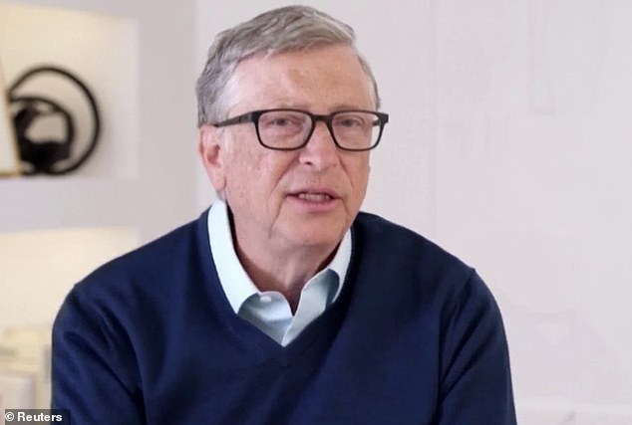

+11

**Bill Gates says he has been taken aback by the volume of ‘crazy’ and ‘evil’ conspiracy theories that have been spreading about him on social media during the COVID-19 pandemic**

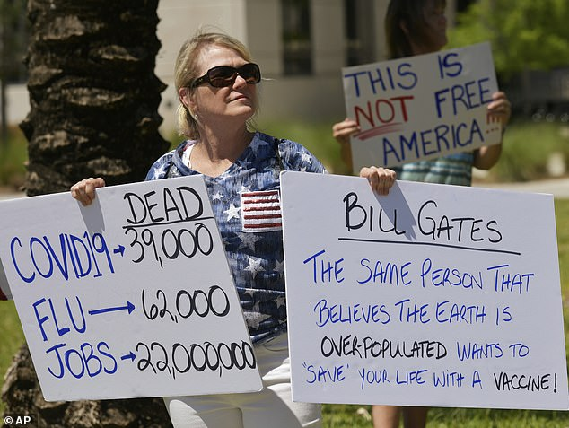

+11

**Health professionals say vaccine misinformation could have lethal consequences if it leads people to opt for bogus cures instead**

**Bill Gates surprised by pandemic conspiracies**

Loaded: 0%

Progress: 0%

0:00

Previous

Play

Skip

Mute

Current Time0:00

/

Duration Time5:42

Fullscreen

Need Text

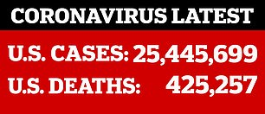

Gates, a billionaire who stepped down as chairman of Microsoft Corp in 2014, has through his philanthropic Bill and Melinda Gates Foundation committed at least $1.75 billion to the global response to the COVID-19.

Since the pandemic began a year ago,conspiracies have spread over the internet, fueling misinformation about the coronavirus, its origins and the motives of those working to fight it.

In the first few months of the pandemic alone, between February and April last year, conspiracy theories and misinformation linking Gates to the origins of COVID-19 were mentioned more than 1.2 million times on television and social media, [**according to a New York Times study**](https://www.nytimes.com/2020/04/17/technology/bill-gates-virus-conspiracy-theories.html).

Then, in May 2020, a [**Yahoo News/You Gov**](https://news.yahoo.com/new-yahoo-news-you-gov-poll-shows-coronavirus-conspiracy-theories-spreading-on-the-right-may-hamper-vaccine-efforts-152843610.html)poll found that 28 percent of US adults believed that Gates was plotting to use a potential vaccine to implant microchips into billions of people to track their movements.

Meanwhile, other conspiracies gathered momentum that included claims Gates was seeking to cull 15 percent of the population with the vaccine, and he was also falsely quoted as saying the vaccine would ‘no doubt’ kill 700,000 people.

At Trump rallies, anti-lockdown protests, and Q-Anon drives, countless participants have been observed holding signs supporting the Gates conspiracies, that often include the tagline '#SayNoToBillGates'.

**RELATED ARTICLES**

* [Previous](https://www.dailymail.co.uk/news/article-9192815/Bill-Gates-says-hes-shocked-crazy-evil-conspiracy-theories-linking-COVID-19.html)
* [1](https://www.dailymail.co.uk/news/article-9192815/Bill-Gates-says-hes-shocked-crazy-evil-conspiracy-theories-linking-COVID-19.html)
* [Next](https://www.dailymail.co.uk/news/article-9192815/Bill-Gates-says-hes-shocked-crazy-evil-conspiracy-theories-linking-COVID-19.html)
* [**[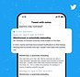](https://www.dailymail.co.uk/news/article-9186073/Twitter-launches-fact-checking-program-called-Birdwatch-member-flag-tweet.html)Twitter launches fact-checking program called Birdwatch...**](https://www.dailymail.co.uk/news/article-9186073/Twitter-launches-fact-checking-program-called-Birdwatch-member-flag-tweet.html)[**[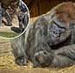](https://www.dailymail.co.uk/news/article-9188367/Elderly-gorilla-given-antibody-treatment-suffering-case-COVID-19-San-Diego-Zoo.html)Elderly silverback gorilla is given antibody treatment while...**](https://www.dailymail.co.uk/news/article-9188367/Elderly-gorilla-given-antibody-treatment-suffering-case-COVID-19-San-Diego-Zoo.html)

**SHARE THIS ARTICLE**

Share

The genesis of the distorted theories is believed to date back to a 2015 video, when, during a TED Talk in Vancouver, Gates issued a dire warning that, ‘if anything kills over 10 million people over the next few decades, it is likely to be a highly infectious virus, rather than a war.’

Conspiracy theorists claim the premonition is proof that Gates had prior knowledge about the coronavirus.

During his Wednesday interview with Reuters, Gates asked: ‘But do people really believe that stuff?

‘We’re really going to have to get educated about this over the next year and understand... how does it change peoples’ behavior and how should we have minimized this?’

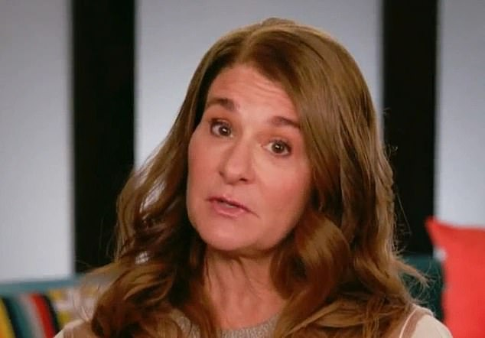

+11

**Gates' wife, Melinda Gates, also spoke out about the theories involving her husband Wednesday, telling GMA : 'Disinformation causes more death. It causes people not to do the right things.**

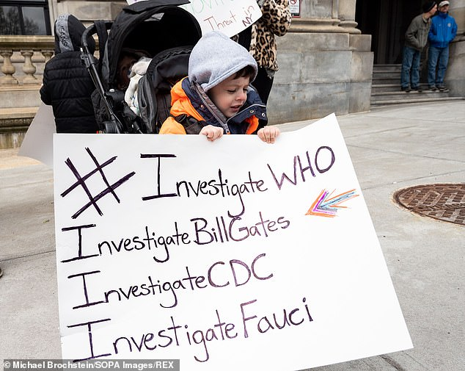

+11

**In the first few months of the pandemic alone, between February and April last year, conspiracy theories and misinformation linking Gates to the origins of COVID-19 were mentioned more than 1.2 million times**

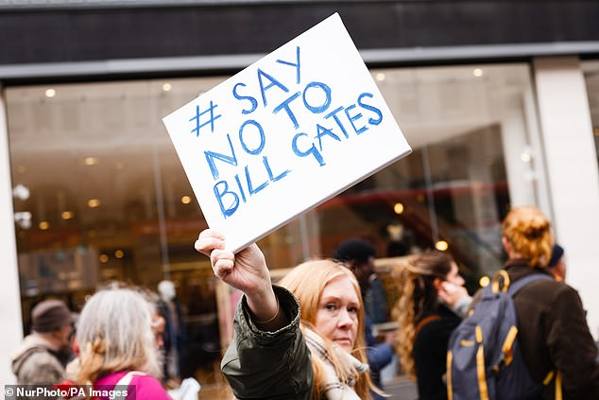

+11

**During his Wednesday interview with Reuters, Gates asked: ‘But do people really believe that stuff?'**

**What Are Some of the Bill Gates Conspiracy Theories?**

The main conspiracy theory involving Gates is that he intends to use the COVID-19 vaccine to implant a microchip into the arms of billions of people to track their movements.

A theory that Gates wanted to cull 15 percent of the population through the vaccine has also been peddled, as have false claims that he developed the deadly virus in a lab.

Other baseless theories include:

* The Bill and Melinda Gates Foundation has tested vaccines on children in Africa and India, leading to thousands of deaths and irreversible injuries.
* He is accused of rolling out a tetanus vaccine in Kenya that includes abortion drugs.
* Gates falsely accused of saying the COVID vaccine would 'no doubt' kill at least 700,000 people.

ADVERTISEMENT

[](https://crta.dailymail.co.uk/_/e?r=https%3A%2F%2Fwww.newzit.com%2F%3Fito%3DMOL_House_Ads&e=)

Gates offered a similar bemusement to the conspiracies during a key-note address at the World Congress of Science & Factual Producers in December.

‘I’m surprised at all the conspiracy theories — people who think the vaccine is not meant to save lives. That’s all wrong, but the scale of it is a bit scary in terms of, will that prevent people from being willing to take the vaccine, and why are they looking for these simple explanations?’

Gates said the goal of his foundation's vaccine development work is to advance public goods for global health through technological innovation by accelerating the development and commercialization of novel vaccines and the sustainable manufacture of existing ones.

‘Even [U.S. coronavirus expert] Dr. Fauci or myself, our basic motivation for being involved in this work has been questioned; maybe there’s something malign about that,’ Gates said. ‘I’m hopeful that the digital tools can get the truth out, as well as it’s gotten these conspiracy theories out.’

Melinda Gates also discussed the conspiracy theories in a Wednesday morning interview with[**Good Morning America**](https://www.cbsnews.com/news/melinda-gates-covid-19-conspiracy-theories-disinformation/).

When asked by host Gayle King whether she was aware of the theories, Melinda replied: 'I certainly heard many of those conspiracy theories...that disinformation causes more death. It causes people not to do the right things.

'If you take up one conspiracy theory on the internet, we now know these social media platforms will serve up many, many more. And so people start do go down those dark holes.'

She continued: 'I absolutely think social media... the tech companies and platforms need to look at these issues and address them. ... It's time to have more government regulation over the social platforms, so we don't get these conspiracy theories that cause more death.'

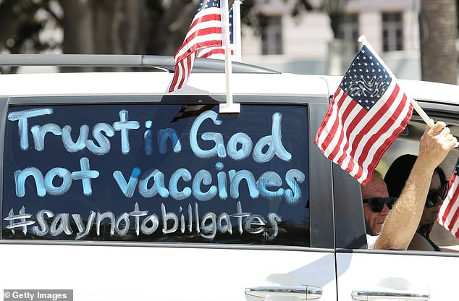

+11

**At Trump rallies, anti-lockdown protests, and Q-Anon drives, countless participants have been observed holding signs supporting the Gates conspiracies, that often read '#SayNoToBillGates'**

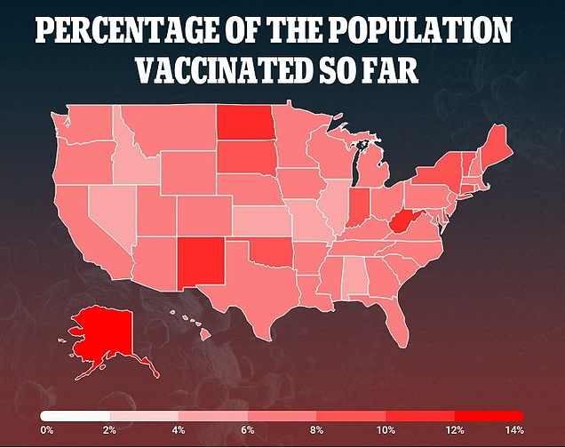

+11

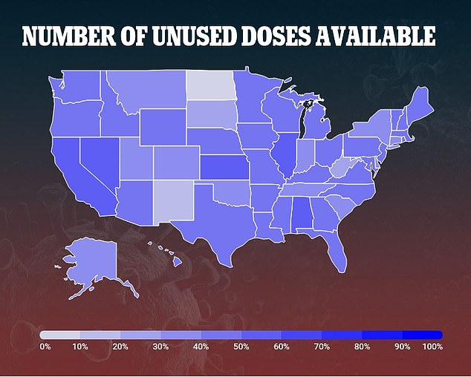

+11

**Poll Finds 47% of US Want the Vaccine 'As Soon as Possible'**

Nearly half of all Americans want to get the COVID-19 vaccine as soon as they can, a new poll released Wednesday suggests.

That percentage is even higher among those who know someone who has already been vaccinated.

The poll, conducted by the Kaiser Family Foundation just before President Joe Biden took office one week ago shows Americans are far less hesitant to take the Coronavirus vaccines with 47 percent of the public wanting to get the vaccine as soon as possible or they have already been vaccinated.

This is a dramatic increase from the one-third – or 34 percent – of the US public that wanted to be vaccinated ‘as soon as possible’ in a December Kaiser poll before vaccines were cleared by regulators.

Another 31 percent say they want to ‘wait until it has been available for a while to see how it is working for others.’

But 20 percent are more reluctant to get vaccinated, including 7 percent who will only get vaccinated ‘if required to do so for work, school or other activities,’ and 13 percent who say they will ‘definitely not’ get the vaccine, the survey found.

ADVERTISEMENT

[](https://crta.dailymail.co.uk/_/e?r=https%3A%2F%2Fwww.newzit.com%2F%3Fito%3DMOL_House_Ads&e=)

Bill Gates, who is America's biggest owner of private farmland, is among the world's richest people, with only Tesla CEO Elon Musk and Amazon’s Jeff Bezos boasting deeper pockets.

Prof Joseph Uscinski, a political scientist at the University of Miami and author of books on conspiracy theories, told the [**BBC**](https://www.bbc.com/news/52847648)last year said Gates has become a ‘voodoo doll’ of conspiracies simply because he is rich and famous.

‘Conspiracy theories are about accusing powerful people of doing terrible things,’ he said. ‘The theories are basically the same, just the names change.

‘Before Bill Gates, it was George Soros and the Koch brothers and the Rothchilds and the Rockefellers.’

While Uscinski says the majority of conspiracy theories ‘die on the vine’, the ones that endure are those that offer ‘big villains and address issues that people care about’.

‘It should come as no surprise that rich people and big corporations are being accused of conspiring to put chips in our necks because that is a thing we fear,’ he said. ‘This has been the ammo of conspiracy theories for a long, long time.’

The rise of social media has also helped to propel theories such as the ones involving Gates into the public sphere.

‘Before the internet, they were self-contained and existed only in their own echo chambers or bubbles within certain communities, but the internet allows them to travel across political lines, between communities, so I think there is much more scope to mainstream conspiracy theories than before the internet,’ Rory Smith, from fact-checkers First Draft News, also told the [**BBC**](https://www.bbc.com/news/52847648).

He added that conspiracy theories have particularly flourished amid the pandemic because people are more ‘psychologically vulnerable.’

‘This crisis is unprecedented in size and scope and the advice shifts as new studies are published. There are large areas of uncertainty and humans abhor uncertainty,’ Smith said.

‘We grab onto any information to inject some sort of sense and order and that is when the rumor mill starts. Conspiracy theories - and notably Bill Gates conspiracy theories - fill these informational vacuums.’

Looking ahead, Gates praised Dr. Fauci and Francis Collins, head of the U.S. National Institutes of Health, as ‘smart’ and ‘wonderful people’ to Reuters on Wednesday.

Gates said he’s looking forward to seeing them be able to work effectively and speak the truth under the new administration of Joe Biden.

During former President Donald Trump’s handling of the pandemic, Gates said, it had ‘sometimes felt like they were the only sane people in the U.S. government.’

‘I’m excited about the team that Biden has picked’ to tackle the health crisis, Gates said.

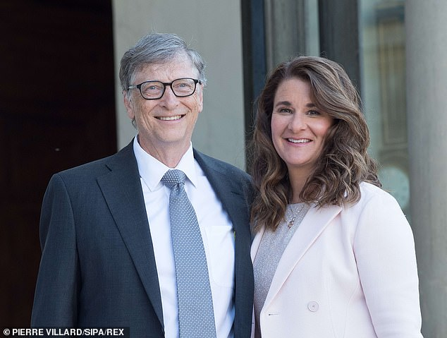

+11

**Gates, a billionaire who stepped down as chairman of Microsoft Corp in 2014, has through his philanthropic Bill and Melinda Gates Foundation committed at least $1.75 billion to the global response to the COVID-19**

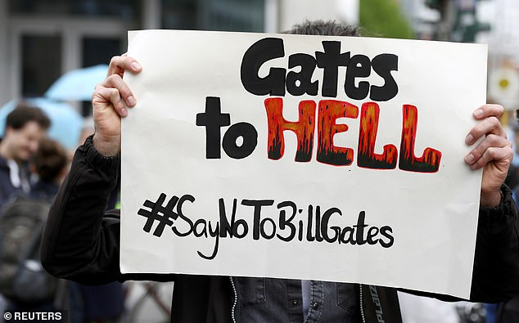

+11

**The rise of social media has also helped to propel theories such as the ones involving Gates into the public sphere, as people are said to be more 'psychologically vulnerable'**

Gates said he was also pleased that under Biden, the United States has rejoined the World Health Organization, and ‘that he’s appointed smart people, and the fact that Dr. Fauci won’t be suppressed.’

The United States began vaccinations five weeks ago, however just 6.2 percent of the population have so far received their first doses of either Pfizer's or Moderna's two-dose vaccines.

Currently, the US is vaccinating 1.27 million people a day on average. Biden said Monday he wanted to increase that number to 1.5 million per-day, in the days ahead.

A poll released by the Kaiser Family Foundation on Wednesday found that 47 percent of Americans want to get the COVID-19 vaccine 'as soon as possible.'

Conducted just one week before Biden took office, the results shows the US is less hesitant to get the vaccine than they were back in December, when just 34 percent said they wanted it immediately.

Another 31 percent say they want to ‘wait until it has been available for a while to see how it is working for others.’

But 20 percent are more reluctant to get vaccinated, including 7 percent who will only get vaccinated ‘if required to do so for work, school or other activities,’ and 13 percent who say they will ‘definitely not’ get the vaccine, the survey found.

It comes as the US death toll rose to 425,257, including 3,990 on Tuesday. More than 25 million Americans have been diagnosed with COVID-19 since the start of the pandemic.

Encouragingly, cases, deaths and hospitalizations were all down last week compared to previous weeks, but deaths remains high with an average of 3,287 people dying a day.

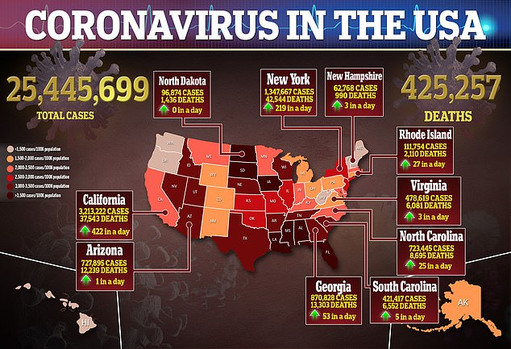

+11

**Read more:**

* [**New Yahoo News/YouGov poll shows coronavirus conspiracy theories spreading on the right may hamper vaccine efforts**](https://news.yahoo.com/new-yahoo-news-you-gov-poll-shows-coronavirus-conspiracy-theories-spreading-on-the-right-may-hamper-vaccine-efforts-152843610.html)
* [**Coronavirus: Bill Gates ‘microchip’ conspiracy theory and other vaccine claims fact-checked - BBC News**](https://www.bbc.com/news/52847648)
* [**Bill Gates, at Odds With Trump on Virus, Becomes a Right-Wing Target - The New York Times**](https://www.nytimes.com/2020/04/17/technology/bill-gates-virus-conspiracy-theories.html)
* [**Melinda Gates on her mission to fight COVID-19 and how conspiracy theories "cause more death" - CBS News**](https://www.cbsnews.com/news/melinda-gates-covid-19-conspiracy-theories-disinformation/)